

|  |
| --- |
|  |
| Request for Proposals  Western Nassau Resources  (“RFP” or “2016 WN RFP”)  Issued on January 26, 2016 by  PSEG Long Island LLC  Through its operating subsidiary,  Long Island Electric Utility Servco LLC  As agent of and acting on behalf of  Long Island Lighting Company d/b/a LIPA  Addendum 1: Issued February 5, 2016 |
|  |

Table of Contents

1. Introduction and Background 1

1.1. Company Overview 1

1.2. Solicitation Overview and Objectives 1

1.3. Far Rockaway Load Area and Glenwood Load Areas 2

1.4. Resource Requirements at the Far Rockaway and Glenwood Load Areas 3

1.5. Proposal Options 5

1.6. Load Reduction Resource Requirements 5

1.7. Power Production and Other Resource Requirements 5

1.8. RFP Schedule & Other Relevant Dates 5

2. Terms and Conditions 7

2.1. Commercial Operating Date 7

2.2. Alternative Commercial Operating Dates 7

2.3. Form of Agreement 7

2.4. Treatment of Interconnection Costs 7

2.5. Firm Pricing Commitment 8

2.6. Conditions Precedent for Agreement 8

3. Proposal requirements 9

3.1. General Requirements 9

3.2. Proposal Outline and Content 10

4. Administrative Matters 27

4.1. Interpretation or Correction of RFP Documents 27

4.2. Proposal Expenses 27

4.3. Proposal Submittal Fee 27

4.4. Proposal Submittal Requirements 28

4.5. Communication during RFP Process 29

4.6. RFP Website 30

4.7. Questions about the RFP 30

4.8. Request for T&D System Data 30

4.9. Limitations 31

4.10. NYS MWBE Participation/Equal Employment Opportunity 31

4.11. NYS Service-Disabled Veteran-Owned Businesses 32

5. evaluation & selection process 33

5.1. Evaluation Process 33

5.2. Right to Reject Proposals 34

5.3. Right to Bifurcate Proposal Selection 34

5.4. Evaluation Criteria 35

5.5. Selection Process 37

5.6. Notice of Award 37

5.7. Contract Approval 37

5.8. Material Changes 38

5.9. Debriefing of Unsuccessful Respondents 39

APPENDIX a: LOAD REDUCTION RESOURCE SPECiFICATIONS 1

A1. Load Reduction Background 1

A2. Far Rockaway and Surrounding Load Areas 1

A2.1. Customer Characteristics 6

A3. Glenwood Load Area 10

A3.1. Customer Characteristics 14

A4. ROLES AND RESPONSIBILITIES (AS APPLICABLE) 17

A4.1. PSEG Long Island Responsibilities 17

A4.2. Respondent Responsibilities 18

A5. PERFORMANCE (AS APPLICABLE) 20

A5.1. Performance Metrics 20

A5.2. Penalties for Callable Resources 20

A5.3. Penalties for Distributed Generation Resources 20

A6. VOLTAGE RIDE-THROUGH CAPABILITY (AS APPLICABLE) 21

Appendix B: POWER PRODUCTION SPECIFICATIONS & OTHer 1

B1. POWER PRODUCTION RESOURCES 1

B2. APPLICABLE RULES AND STANDARDS 1

B2.1. NYISO and LIPA Interconnection Rules 1

B2.2. NPCC Standards 1

B3. System Dispatch and Bidding 2

B4. Locational Requirements and Information 2

B4.1. Storm-Resistant Location and Facilities 2

B4.2. Site Control 2

B4.3. Resource Interconnection Point 2

B4.4. Fuel Supply 2

B4.5. Environmental Conditions 2

B5. Electrical System Characteristics 4

B5.1. Existing Short-Circuit Current 4

B5.2. Steady-State Electrical Characteristics 4

B5.3. Temporary Voltages and Frequencies 5

B5.4. Fault Clearing Times 8

B5.5. Existing Transmission-Connected Power Electronic Systems 8

B6. Resource Capacity and Dispatch Response 9

B6.1. Site Continuous Power Capacity 9

B6.2. Power Dispatch Response 10

B6.3. Reactive Power Capacity 11

B7. Availability 11

B7.1. Availability Definitions 11

B7.2. Availability Warrantee 12

B7.3. Availability Measurement Period 12

B7.4. Minimum Undeclared Outage Duration 13

B8. Control System and Operations Interface Requirements 13

B8.1. Automatic Voltage Regulator 13

B8.2. Frequency Regulation 13

B8.3. Power Production Resource Stability 13

B8.4. EMS System Interface 14

B9. Harmonics and Interference 15

B9.1. Harmonic Performance Metrics 15

B10. Radio Frequency Interference 16

B11. Developer Attachment Facilities (DAF) 16

B11.1. DAF Interconnection Step-Up Transformer 16

B11.2. DAF Termination 16

B11.3. Interconnection Circuit Breaker 16

B11.4. Communication Facilities and Interface 17

B11.5. Auxiliary Power 17

B12. Interconnection Protection 17

B12.1. Protective Relays 17

B12.2. Recording and Monitoring Devices 18

B13. Metering 18

B14. Power Production Resource Models 19

B14.1. Synchronous Machine Models 19

B14.2. Power Converter Positive-Sequence Models 19

B14.3. Power Converter Electromagnetic Transient Models 19

B14.4. Short-Circuit Characterization 20

B15. Design Studies 21

B15.1. Study Timing 21

B15.2. Study Data 21

B15.3. Study Review 21

B16. System Verification and Testing 22

B17. Training 22

# Introduction and Background

## Company Overview

The Long Island Lighting Company d/b/a LIPA (“LIPA””), a corporation organized and existing under the laws of the State of New York is a wholly owned subsidiary of the Long Island Power Authority, a corporate municipal instrumentality and political subdivision of the State of New York. LIPA, through its agent, PSEG Long Island LLC, provides electric service to approximately 1.1 million customers in its service area, which includes Nassau County, Suffolk County, and the portion of Queens County known as the Rockaways, in the State of New York.

LIPA has secured power supply resources consisting primarily of various power purchase contracts with third-party generation and transmission developers to meet its customers’ electricity requirements, and has undertaken a variety of demand-side initiatives to reduce system peak demand (e.g., offered incentive programs to customers to encourage them to adopt energy efficiency measures, install wind and solar electricity-generating systems, and participate in Load Reduction events).

Pursuant to the Amended and Restated Operation Services Agreement (“A&R OSA”) dated December 31st, 2013, as it may be restated, amended, modified, or supplemented from time to time, between LIPA and PSEG Long Island, PSEG Long Island through its operating subsidiary, Long Island Electric Utility Servco (“Servco”), assumed the responsibility as LIPA’s service provider to operate and manage LIPA’s transmission and distribution system (“T&D System”) and other utility business functions as of January 1st, 2014. On January 1st, 2015, PSEG Long Island assumed the additional responsibility for LIPA’s power supply planning, and its affiliate provides certain other services, such as purchasing power and fuel procurement, to LIPA related to these responsibilities. Additional information about LIPA and PSEG Long Island can be found on their respective websites - [www.lipower.org](http://www.lipower.org) and [www.psegliny.com](http://www.psegliny.com).

PSEG Long Island and Servco (collectively referred to as “PSEG Long Island”), as agent of and acting on behalf of LIPA per the A&R OSA, will administer this RFP on behalf of LIPA. The Forms of Agreement for this solicitation will be either Purchase Power Agreements (“PPAs”) between LIPA and the selected Respondents for projects that employ power production resources, or Service Contracts between the selected Respondents and PSEG Long Island for load reduction resources. PPAs shall be subject to approval by the LIPA Board of Trustees, the New York State Attorney General, and the New York State Office of the State Comptroller.

## Solicitation Overview and Objectives

The North American Electric Reliability Corporation (“NERC”) is responsible for the development and enforcement of reliability standards for North America’s bulk power transmission system, including Transmission Planning (“TPL”) standard TPL-001-4, which mandates the Transmission Planner to design for the loss of two bulk transmission elements, commonly referred to as N-1-1. PSEG Long Island has determined that the Western Nassau area of the Company’s transmission system, described herein as the Far Rockaway Load Area (“Far Rockaway”) and the Glenwood Load Area (“Glenwood”), requires system upgrades by December 31, 2020 in order to meet the performance requirements of TPL-001-4.

The Company seeks to meet its reliability obligations at Far Rockaway and Glenwood in the most economical manner possible consistent with Company and State policies. Notably, a transmission solution at both locations is considered a potentially viable economic alternative. The addition of supply side resources and load reduction measures, however, may prove to be more economic than a transmission solution and the Company is requesting such solutions at both Far Rockaway and Glenwood for evaluation against the transmission alternative(s). As a result, this RFP will evaluate conventional generation, energy efficiency, demand response, distributed energy resources, energy storage, and renewables against the transmission alternative(s).

Importantly, due to the critical and time sensitive nature of the reliability situation, Respondents are required to submit Proposals that offer a complete solution, i.e., a Proposal that meets the minimum resource requirements, as defined in Section 1.4, for either or both the Glenwood and Far Rockaway Load Areas. Resource solutions in the two load areas are interdependent.

A Respondent may submit Proposals for each the Far Rockaway and Glenwood Load Areas but those Proposals must be submitted separately and each Proposal will be evaluated and selected independently of the other. A Proposal that does not provide the minimum resource requirement for the respective area will be deemed non-responsive and not evaluated.

## Far Rockaway Load Area and Glenwood Load Areas

### Far Rockaway Load Area

The portion of the T&D System that supplies the Rockaways of Long Island is a peninsular, semi-isolated load pocket with limited transmission capabilities to the surrounding areas. The busses in the Far Rockaway and surrounding area that impact the transmission need are identified in Appendix A, Section A2. That section of the RFP also presents a “zip code” map, useful for supporting the development of Load Reduction resources. Transmission maps of the Western Nassau Area (i.e., Far Rockaway and Glenwood) will be provided upon request. Completion of a PSEG Long Island non-disclosure agreement (“NDA”) and a Critical Energy Infrastructure Information (“CEII”) NDA are required.

### Glenwood Load Area

The Glenwood load area is located in the northwestern portion of the Long Island transmission system. The busses in the Glenwood and surrounding area that impact the transmission need are identified in Appendix A, Section A3. That section of the RFP also presents a “zip code” map, useful for supporting the development of Load Reduction resources. Transmission maps of the Western Nassau Area (i.e., Far Rockaway and Glenwood) will be provided upon request. Completion of a PSEG Long Island non-disclosure agreement (“NDA”) and a Critical Energy Infrastructure Information (“CEII”) NDA are required.

## Resource Requirements at the Far Rockaway and Glenwood Load Areas

### Far Rockaway Load Area

As shown in Table 1-1, a minimum of 160 MWs of additional resources is required by December 31, 2020 increasing yearly to a total additional resource requirement of 275 MWs by the peak load period of 2030. The 275 MWs will be required to remain in service through the year 2039. Respondents submitting Proposals to address resource needs in Far Rockaway must provide at least the minimum resource requirement in every year between 2020 and 2030 through the application of power production resources or a combination of power production and load reduction resources. In addition, as shown in Table 1-1, power production resources must provide a minimum amount of the total resource requirement in each year. Requirements for load reduction resources, if proposed, are specified in Appendices A and B. While proposed resources may be installed in phases, the preference is to have an installed amount above the required minimum MWs in each year in order to ensure that reliability is met under potentially varying conditions.

Respondents should be aware that power production resources will need to connect at the Far Rockaway 69 kV bus and that transmission reinforcements will be necessary to facilitate this connection. The Respondent almost certainly will bear the cost of such reinforcements. Preliminary estimates of the cost (in 2015 dollars) of the transmission reinforcements, based on the size of the proposed power production resource, are in the following ranges:

* Less than 170 MWs: $30 million - $53 million
* 171 MWs – 275 MWs: $45 million - $75 million
* 276 MWs – 301 MWs: $55 million - $90 million
* 311 MWs – 339 MWs: $65 million - $100 million

The actual costs for system upgrades, as determined through the interconnection process for a specific proposed project, may be higher or lower than these preliminary estimates. These costs will impact the economic evaluation of a Proposal that includes power production resources.

Proposed resources must be available during the days and times-of-day described in Appendices A and B.

**Table 1-1: Far Rockaway Resource Requirement (MWs)**

|  |  |  |  |  |  |  |  |  |  |  |  |
| --- | --- | --- | --- | --- | --- | --- | --- | --- | --- | --- | --- |
| **Year-End** | **2020** | **2021** | **2022** | **2023** | **2024** | **2025** | **2026** | **2027** | **2028** | **2029** | **2030** |
| **Minimum Total Requirement** | 160 | 166 | 172 | 178 | 184 | 190 | 207 | 224 | 241 | 258 | 275 |
| **Minimum Pwr. Production** | 140 | 145 | 150 | 155 | 160 | 165 | 180 | 195 | 210 | 225 | 240 |

### Glenwood Load Area

As shown in Table 1-2, a minimum of 100 MWs of additional resources is required by December 31, 2020. There are no additional minimum resource requirements beyond the 100 MWs in the period 2020 to 2030. The 100 MWs will be required to remain in service through 2039. Respondents submitting Proposals to address resource needs in the Glenwood Load Area must provide at least the minimum resource requirement, i.e., 100 MWs, in every year between year-end 2020 and 2030 through the application of power production resources, or a combination of power production and load reduction resource. In addition, as shown in Table 1-2, power production resources must provide a minimum amount of the total resource requirement in each year. Requirements for load reduction resources, if proposed, are specified in Appendices A and B.

Power production resources will need to connect at the Glenwood 69 kV bus. Installation of a power production resource(s), or cumulative total power production resources, greater than 225 MWs in any year during the period 2020 – 2030 may necessitate investment in additional transmission reinforcements, which could impact the economic evaluation of a Proposal that includes such a requirement. The additional transmission investment costs have not been identified as yet. Such costs will impact the economic evaluation of a Proposal that includes power production resources.

Proposed resources must be available during the days and times-of-day described in Appendices A and B.

**Table 1-2: Glenwood Resource Requirement (MWs)**

|  |  |  |  |  |  |  |  |  |  |  |  |
| --- | --- | --- | --- | --- | --- | --- | --- | --- | --- | --- | --- |
| **Year-End** | **2020** | **2021** | **2022** | **2023** | **2024** | **2025** | **2026** | **2027** | **2028** | **2029** | **2030** |
| **Minimum Total Requirement** | 100 | 100 | 100 | 100 | 100 | 100 | 100 | 100 | 100 | 100 | 100 |
| **Minimum Pwr. Production** | 75 | 75 | 75 | 75 | 75 | 75 | 75 | 75 | 75 | 75 | 75 |

### Transmission Solutions

As noted earlier, transmission solutions have been identified as being potentially viable economic alternatives to the addition of resources needed to address the reliability needs in both the Far Rockaway and Glenwood load areas.  Preliminary ranges of cost estimates (in 2015 dollars) for transmission solutions at both load areas, shown below, may be useful to Respondents in preparing Proposals.

* Glenwood: $170 million - $250 million
* Far Rockaway: $127 million - $190 million

If implemented, the actual costs for transmission solutions may be higher or lower than the above preliminary estimates.

## Proposal Options

### Respondents may submit separate Proposals for complete solutions at Glenwood and Far Rockaway, or multiple proposals for each location, but each Proposal will be evaluated and selected independently and will require separate submittal fees.

### Proposals may include more than one resource type or technology to meet the requirements at either Far Rockaway or Glenwood. Proposals that include multiple technologies or resource types must provide separate pricing for each technology or resource type so as to facilitate Proposal evaluation.

### Proposals that provide solutions that contain greater than the minimum amount of resources may receive additional value in the evaluation process with respect to increased avoided transmission costs and/or reduced administrative costs, as applicable.  Additionally, there is a preference for project in service dates earlier than those stated, if practical.

## Load Reduction Resource Requirements

Respondents offering load reduction resources must meet the specific roles and responsibilities outlined in Appendix A, as well the specifications and requirements outlined in Appendix B.

## Power Production and Other Resource Requirements

Respondents offering power production resources must meet the requirements and specifications outlined in Appendix B.

## RFP Schedule & Other Relevant Dates

Responses to this RFP are due no later than May 13, 2016 at 3:00 PM EPT. For further information, please refer to the 2016 WN RFP website accessible through PSEG Long Island’s website at [www.psegliny.com](http://www.psegliny.com) or directly at <http://www.psegliwnrfp.com/Index.html>. The RFP Schedule, below, is based upon expectations as of the release date of this RFP. PSEG Long Island may modify the RFP Schedule at its sole discretion.

**Table 1-3: RFP Schedule & Other Relevant Dates**

|  |  |
| --- | --- |
| **RFP Schedule** | |
| **Activity** | **Date** |
| Release of RFP | January 26, 2016 |
| Pre-bid Conference Webinar | February 11, 2016, 3:00 pm EPT |
| Question Submittal Deadline | April 15, 2016, 5:00 pm EPT |
| Notice of Intent to Bid Deadline | April 29, 2016 |
| Proposal Submittal Deadline | May 13, 2016, 3:00 pm EPT |
| Proposal(s) Selection(s) (planned)1 | September 14, 2016 |
| Execution of Contract(s) (planned)2 | December 31, 2016 |
| **Other Relevant Dates** | |
| **Activity** | **Date** |
| Firm Pricing Required Through | January 31, 2018 |
| Latest Commercial Operation Date3 | December 31, 2020 |
| 1 All Respondents will be notified in writing once the selections are completed.  2 Execution of a contract is dependent upon completion of negotiations, and for resources requiring SEQRA, it is also dependent upon receipt of SEQRA findings.  3 All Respondents must commit to meeting the minimum resource requirements needed for compliance by year-end 2020 in either or both the Far Rockaway or Glenwood Load Areas, as described in Section 1.4. In addition, for Far Rockaway, Proposals that contain resources that will be phased in over the term of the contract must commit to meeting the minimum resource requirements for year-end 2020 as well as the yearly total resource requirements between 2021 and 2030 that are identified in Table 1-1. | |

*****

# Terms and Conditions

## Commercial Operating Date

Commercial operation for all resources at either the Far Rockaway or Glenwood Load Areas must take place by December 31, 2020.

## Alternative Commercial Operating Dates

If feasible under the RFP schedule described in Section 1.8, Respondents are encouraged to propose an alternative COD earlier than the latest COD. Selection of COD will be made during proposal selection. There is a preference for in service dates earlier than that required, if practical.

## Form of Agreement

The Forms of Agreement for this solicitation will be either Purchase Power Agreements (“PPAs”) between LIPA and the selected Respondents for projects that employ power production resources, or Service Contracts between PSEG Long Island and the selected Respondents for projects that employ load reduction resources. Draft PPAs and Service Contracts will be made available on a dedicated website associated with this RFP (<http://www.psegliwnrfp.com/Index.html>) that can also be accessed from the main PSEG Long Island website ([www.psegliny.com](http://www.psegliny.com)). Depending on a Respondent’s Proposal there could be up to three (3) agreements required; one for dispatchable resources, one for non-dispatchable resources connected to the LIPA electrical system, and one Service Contract for load reduction technologies. For any Proposal that requires multiple agreements, such agreements will contain cross default provisions so that a default on any one of the agreements would potentially result in a default on all of the agreements covered by the Proposal.

Proposals shall be for a term that runs through December 31, 2039.

## Treatment of Interconnection Costs

Power production and load reduction resource proposals must comply, as appropriate, with the NYISO Large Generator Interconnection Procedure, the NYISO Small Generator Interconnection Procedure, or LIPA’s Smart Grid Small Generator Interconnection Procedures. Relevant links are as follows:

<http://www.lipower.org/company/papers/interconnect.html>.

<https://www.psegliny.com/page.cfm/AboutUs/CompanyProfile/Powering/SGIP>

Additionally a project must satisfy the requirements outlined in the LIPA T&D design criteria as applicable. This document can be found at:

http://www.lipower.org/pdfs/company/projects/energyplan10/energyplan10-e6.pdf

In keeping with LIPA’s policy of non-discriminatory access to its T&D System, Respondents will be responsible for reimbursing LIPA (as Connecting Transmission Owner) for all attachment facilities and system upgrades constructed and owned by LIPA. Respondents may seek to recover such costs through agreement charges. If the Respondent desires a recovery provision, it must be identified in the Respondent’s Proposal. Any such provisions will be considered in the evaluation of the proposals received.

## Firm Pricing Commitment

All proposed contract pricing must be firm and all terms and conditions must be open for acceptance by PSEG Long Island through January 31, 2018. Firm pricing may include fixed prices and prices that are subject to adjustment based on publicly available indices. Costs that cannot reasonably be forecasted may be subject to “pass-through,” provided they are adequately defined in the contract. During evaluation of Proposals, any such pass-through(s) will increase the risk assessment of proposals.

Pricing must include any and all costs to fully meet the 30% NYS Certified Minority and Women Owned Business Enterprise subcontracting goals and the NYS Certified Service-Disabled Veteran-Owned Business goal of 6%. This requirement for submitting pricing to meet the full goals also applies to firms that are seeking full or partial waivers of the goals.

## Conditions Precedent for Agreement

State Law prohibits LIPA from executing an agreement for a project that is subject to review under the New York State Environmental Quality Review Act (“SEQRA”) until the SEQRA review is complete.  In addition, for a proposed Project subject to Article 10 of the New York Public Service Law, a condition precedent to the PPA becoming effective is that the Respondent must receive a certificate of environmental compatibility and public need from the New York State Board on Electric Generation Siting and the Environment.

*****

# Proposal requirements

## General Requirements

Respondents may submit Proposals to meet the resource requirements for either or both Far Rockaway and Glenwood, but if a Respondent submits Proposals for each area then each Proposal must be submitted independently and will be evaluated separately. In addition, multiple Proposals by a Respondent for either the Far Rockaway or Glenwood Load Areas are permitted but require separately bound copies and additional submittal fees for each proposal, and each proposal will be evaluated separately.

Proposals shall include each of the required elements summarized herein. This applies to each Proposal that is submitted by Respondent (i.e., each Proposal shall stand alone in satisfying these requirements).

1. Proposals that do not include mandatory information will be deemed non-responsive and will not be evaluated.
2. Non-responsive Proposals include, but are not limited to, those that:
3. Are not in conformance with RFP requirements and instructions.
4. Are conditioned on some other act or omission (other than as required by law), whether or not related to this procurement and the resulting contract. Without limiting the generality of the foregoing, by way of example, a proposal that requests extension of an existing contract with the same company is a conditional proposal.
5. Do not include the required Proposal Submittal Fee.
6. Contain any material omission(s).
7. Do not meet other submission requirements set forth herein.

Respondents may submit complementary information not explicitly requested within the RFP documents, however, Proposals shall remain concise while still providing a complete description of the Respondent’s approach, capabilities, key assumptions and pricing for satisfying the required services being solicited in this RFP.

All responses to this RFP shall include details about the ability to meet the resource terms and conditions discussed in Section 2, as well as the Load Reduction and Power Production resource specifications listed in Appendices A and B, respectively.

As a corporate municipal instrumentality of the State of New York, documents in LIPA’s possession are presumptively available to the public under New York’s Freedom of Information Law (“FOIL”), Public Officers’ Law (“POL”) Article 6. Respondents are strongly encouraged to familiarize themselves with the obligations and requirements of FOIL. Consistent with Section 87(2) of the POL, Respondents shall indicate in their Proposal, what information, if any, should not be made publicly available by marking such information as confidential. Information marked confidential will be treated as such to the extent consistent with PSEG Long Island’s and LIPA’s obligations under the Freedom of Information Law (“FOIL”), other applicable law, regulation, or legal process, and will not be disclosed except as required by law, or as necessary for the evaluation of Proposals. In the event that LIPA receives a FOIL request for any or all Proposals submitted in response to this RFP, LIPA will notify the submitting entity of the FOIL request pursuant to Section 89(5) of the POL.

## Proposal Outline and Content

Proposals submitted to PSEG Long Island in response to this RFP are required to follow the below outline in terms of format and sequence. (A Respondent’s Proposal Section numbering may, of course, be different.) Following the outline are Sections corresponding to the outline that provide additional information and guidance regarding the outline item and required information. Note that not all requirements listed within the Proposal outline Sections may be applicable to all resource types. Respondents should exercise judgment when determining whether a Section’s requirement is applicable to their Proposal. Since all Respondents are required to submit Proposals that follow the Proposal Outline, if a Respondent deems a Section (or sub-section) non-applicable it should so state in the relevant Section of its Proposal. In case of doubt as to whether a particular Section is applicable, the Respondent should contact the appropriate designated contact person(s) for this RFP, as identified in Section 4.5.

*Proposal Sections*

3.2.1 Cover Letter

3.2.2 Table of Contents

3.2.3 Executive Summary

3.2.4 Pricing and Costs

3.2.5 Site Information

3.2.6 Development Plans and Schedule

3.2.7 Fuel Supply Plans and Schedule

3.2.8 Technical Response

3.2.9 Electrical Equipment

3.2.10 Design Studies

3.2.11 Factory Tests

3.2.12 Commissioning Tests

3.2.13 Operations Plan

3.2.14 Field Services

3.2.15 Training

3.2.16 Program Management Capabilities

3.2.17 Future Upgrades

3.2.18 Respondent Information and Qualifications

3.2.19 Status and Reporting

3.2.20 Technical Requirements Compliance Statement

3.2.21 Disclosures

3.2.22 Agreement Redline

3.2.23 Procurement Forms

3.2.24 NYS Certified Minority and Women Owned Business Enterprise

3.2.25 NYS Service-Disabled Veteran-Owned Businesses

3.2.26 Glossary & Acronyms

### Cover Letter

1. Signature(s) by the individual(s) that are duly authorized by the Respondent to make a binding offer to LIPA.
2. Contact information for Respondent’s primary point of contact, including name, title, address, phone, email, and fax.
3. Statement clearly indicating the time period during which the Proposal will remain effective. Note: At a minimum, Proposal pricing must remain effective through January 31, 2018.

### Table of Contents

1. Proposals should include a table of contents that clearly lists all items submitted in response to this RFP and that is consistent with the requirements in Section 3.2.

### Executive Summary

1. A brief summary, approximately 2 - 3 pages, of the project’s key features, characteristics, and other distinguishing attributes.

### Pricing & Costs

Proposed pricing shall include all costs, including license fees and permitting fees, associated with the installation and delivery of the proposed solution. Pricing shall also include any and all costs to fully or partially, as applicable, meet the 30% NYS Certified Minority and Women Owned Business Enterprise subcontracting goals and the NYS Certified Service-Disabled Veteran-Owned Business goal of 6%.

#### Pricing

1. Pricing in $/kW-month for capacity and in $/MWh for energy products.
2. Pricing for ancillary services, if any.
3. Pricing for black start capability, if any.
4. Pricing for energy related services, if any.
5. If the Proposal requires the use of fuel, include one of the following pricing mechanisms:

No fuel cost pass-through

Fixed fuel price for the duration of the contract

Fuel price formula indexed to a well-known commodity market index.

Note: Charging energy for electric storage devices will be provided by the Buyer at the prevailing wholesale rate. Liquid fuel, if applicable, must be procured, transported and stored by the Respondent. For projects using natural gas as a fuel, the developer is responsible for all associated infrastructure up to the point of interconnection. Proposers must provide pricing adjustments to apply in the event the Buyer elects to assume the responsibilities and costs of natural gas procurement, supply, fuel management or gas transportation services. This pricing adjustment must be exclusive of interstate and local transportation infrastructure, which will remain the Proposer’s responsibility.

1. In addition to the fuel pricing mechanisms previously described, Respondents may provide an alternate fuel pricing mechanism that substantially reduces the volatility of fuel prices paid by PSEG Long Island.

Note: Alternate pricing mechanisms should be described in sufficient detail to allow PSEG Long Island to evaluate and calculate how fuel prices would behave in the context of various fuel prices scenarios.

1. Excel spreadsheet containing all pricing information.

#### Costs

1. Cost of Developer Attachment Facilities recovered through the capacity or energy price, if applicable.
2. Explanation of system upgrade cost recovery method (e.g., pass-through, covered in capacity or energy price).
3. List and justification of any pass-through costs other than fuel prices.
4. Line item breakdown and schedule of total costs.

### Site Information

1. Respondent shall provide evidence of site control or its plan to obtain site control in its Proposal.

Note: The proposed Project, as appropriate, shall be located on a site controlled by Respondent through either fee ownership, a land lease, option to lease or purchase, or equivalent demonstration of site control.

1. Identification of the zoning for the site and a description of whether the proposed Project is a permitted use under the local zoning code or has received a zoning code waiver that will allow the Project to be built and operated.
2. Discussion of any known sensitive environmental features on or adjacent to the site, such as wetlands, historic properties, ongoing hazardous materials remediation, residences or other sensitive noise receptors.
3. Discussion of storm resistant features and other reliability features.
4. Proof of appropriate local zoning or confirmation in writing from the involved municipality that a change in zoning will occur a minimum of one month prior to the “Proposal Selection(s) (planned)” date in Table 1-3, RFP Schedule & Other Relevant Dates, or a waiver from the involved municipality.
5. If permits have already been obtained, Respondent shall provide copies, and if not, Respondent shall provide a plan and schedule for obtaining all required permits.

Note: All permits must comply with any and all State, County, Town or Local Municipality laws, ordinances, or regulations that have been established including those with respect to renewable installations, where applicable.

### Development Plans and Schedule

1. Development schedule for the resource solution, including timetable for:

Community outreach

Permitting

Environmental review

Financing milestones

Contracting milestones

Engineering and design milestones

Major equipment purchases

Construction milestones

Transmission interconnection milestones

Testing

Commercial operation

1. Permitting plan, including a list of all environmental, regulatory and other agency/municipal reviews, permits, and approvals.
2. Information on current site control status and details of plans for obtaining site control.
3. Community outreach plan, including a description of community benefits and evidence of community support.

Note: Community support can be in the form of correspondence from local elected officials and community groups.

1. Information about any Taxes and/or PILOT agreements and plans for negotiation.
2. Plans for the development of any necessary transmission facilities from the generation source to the point of interconnection, if applicable.

### Fuel Supply Plan and Schedule

1. If a fuel is used, a full and complete description of fuel supply plans and schedule.

Note: Where applicable, the fuel supply plan should include plans for liquid fuel storage for a minimum of 5 days of continuous, full power, operation. It shall also incorporate details regarding liquid fuel procurement, supply, and transportation.

### Technical Response

#### Technology Description

Provide a full and complete description of the technology being proposed.

#### One-Line Diagram

Provide a comprehensive one-line diagram describing the electrical equipment and point of interconnection. Note: Compliance with LIPA’s SGIP, the NYISO’s LGIP requirements, and LIPA’s Long Island T&D Design Criteria is required. Respondents may request certain transmission system data to assist them in developing their proposals. PSEG Long Island will provide interested Respondents a load flow, contingency list, and a one-line diagram around an electrical bus at a proposed interconnection point. Respondents should submit a request to Steve Cantore of the Power Asset Management Department, and will be required to execute a LIPA non-disclosure agreement (“NDA”) and a Critical Energy Infrastructure Information (“CEII”) NDA.

#### Site Layout

1. Layout of the Project site using a white background, including site boundaries, access, location of equipment and buildings, and routing of the interconnection line from the Project to the point of interconnection.
2. Layout of the Project using an aerial background, including site boundaries, access, location of equipment and buildings, and routing of the interconnection line from the Project to the point of interconnection.
3. For solar PV projects, provide at a minimum, the following information:

Percent of lot to be covered by solar panels

Setback from property line to nearest solar panel or inverter

Maximum height of any structure

Description of natural screening designed into the Project

#### Resource Performance

1. Description of the concept of operations to be employed in the solution, specifically addressing how the resource shall be made available to respond to transmission support dispatch orders in the required time.
2. Description of the extent the Project can provide/absorb MVARs to control voltage.
3. Description of any known performance limitations that may occur during undervoltage conditions, where voltage drops below 120 V on the feeder’s primary voltage level (i.e., 13.2 kV or 4.16 kV).
4. If power producing devices are used, other than or in addition to synchronous machines, the following short-circuit current characterization shall be provided:

Contribution of each resource to balanced and unbalanced transmission faults, both near and remote from the resource location.

Description of the approach that will be taken to define the detailed short-circuit contribution characteristics of the resource, in both phase and sequence component formats.

1. Dependable Maximum Net Capability (“DMNC”) according to NYISO Standards including (i) expected seasonal peak capacity (MW) for summer and winter and (ii) expected output at ISO conditions.
2. Provide descriptions and assumptions regarding any limitation of fuel availability and/or the ability to use backup fuels for fuel cells and biomass facilities that are fueled with 100% renewable fuel.

#### Resource Environmental Characteristics

1. Description of the technologies and operational strategies that will be used to control air pollutant emissions, as well as related performance. This shall include:

PM10/2.5, NOx, CO, VOC, and NH3 emissions in ppm and lb/hr during normal operation and start up at 32 F, 59 F and 95 F

CO2 emissions in lb/MWh at the design heat rate

Exhaust gas characteristics (e.g., volumetric and mass flow rate, temperature, moisture)

Heat input in MMBtu/hr HHV

1. Information about the water and wastewater requirements, as well as a description of related operational strategies. This shall include:

Water requirements in gallons per minute

Wastewater discharges in gallons per minute

#### Production Forecast[1]

1. For intermittent energy resources, provide projected annual hourly power output at 50%, 90% and 99% probabilities of exceedance (i.e., P50, P90, and P99).
2. Average (P50) annual net energy production forecast (MWhs). This forecast shall represent the average net annual energy delivered to the Long Island electric system at the point of interconnection.
3. Average (P50) hourly net energy production forecast. This forecast shall represent the average hourly net energy delivered to LIPA at the point of interconnection.

Note: The 8760 forecast shall be submitted with the Proposal in electronic form using the Excel format specified in the attachments to be made available on the RFP Website[2]. Do not submit the full 8760 forecast in hard copy format.

1. Uncertainty forecast for the net energy production estimates. This forecast shall present a summary of all estimated uncertainties. Proposals shall include corresponding estimates for P90, P95, and P99 net annual energy production.
2. Description of the assumptions, data, and calculations used to prepare these forecasts.

#### Program Calculation of Impacts

1. For Load Reduction Resources, description of proposed methodology for the calculation of capacity and energy impacts along with the proposed measurement and verification plan.

#### Communication Capabilities

1. Description of communication systems incorporated into the resource for reasons of resource control and/or monitoring.

#### Customer Interaction Capabilities

1. For Load Reduction Resources, a description of customer interaction capabilities, such as contacting Load Reduction customers by the aggregator.

#### Data Sheet(s)

1. Completed data sheet(s) applicable to the technology being proposed.

Note: The data sheets will be issued as part of an addendum to the RFP. Respondents shall print the completed data sheet(s) and include a hard copy within the Proposal as well as submit the completed data sheet(s) electronically in Excel format.

### Electrical Equipment

The following subsections (3.2.9.1 - 3.2.9.7) request information, as applicable, relevant to potential key electrical components of a proposed resource.

#### Power Generation Equipment

The requirements listed on this section apply to proposed solutions that contain any synchronous generators.

1. Manufacturer name of each generator, prime mover, and excitation system.
2. Real (MW) and reactive (MVAR) power ratings of all power generation equipment.
3. Information about any temporary reactive power capability, including the time constraints of such temporary capability.
4. Description of the prime mover and the fuel it uses.
5. Information regarding the Power Generation Equipment’s ability to be bid into the NYISO ancillary services markets.
6. Information about generator electrical parameters (e.g., direct and quadrature axis impedances and time constants, inertia).
7. Information about excitation system characteristics, including ceiling voltage and time response.

#### Electrical Energy Storage Equipment

The requirements listed on this section apply to solutions that contain any electrical energy storage.

1. Manufacturer name and model of the electrical energy storage medium proposed for each solution.
2. Energy and power capacity of the electrical energy storage system, as well as that of the individual components.
3. List of projects with electrical energy storage capacity similar to the capacity proposed, in which this manufacturer’s equipment has been utilized.
4. Description of any limitations to the operation of the resource solution posed by the electrical energy storage medium.
5. Description of any environmental control systems, including heating or cooling, required for the electrical energy storage medium.
6. Information about the susceptibility of the electrical energy storage system to any electrical system disturbances.
7. Information about any degradation of energy storage capacity expected as a result of age or utilization, including an explanation of how this degradation will be addressed (e.g., by planned replacement, redundant capacity) in order to maintain the stated net capability.
8. Description of any environmental hazards presented by the electrical energy storage medium, including an explanation of how these hazards will be mitigated in both facility design and operation.

#### Power Conversion Equipment

The requirements listed on this section apply to resource solutions that contain any electronic power conversion equipment connected directly to the T&D System. This requirement is exclusive of small power converters used for station auxiliaries, excitation supply, power supply to charge batteries for station control, and protection supply; but inclusive of any power converters used to provide reactive power capability.

1. Description of the power conversion equipment, including the name of manufacturer, model, and ratings.
2. Description of the power conversion topology (e.g., two-level voltage source converter, multi-modular voltage source converter, six-pulse thyristor line-commutated converter, etc.).
3. If a voltage-source converter is used, information about the effective switching frequency, and whether the switching is synchronous or asynchronous with respect to the grid voltage.
4. If multiple converters are used, information on whether switching is in any way coordinated between the converters.
5. Description of any cooling, control power supply, or other auxiliary systems critical to the power conversion, including an explanation of the susceptibility of these systems to any electrical system disturbances.
6. Information on whether the proposed power conversion equipment has been tested or certified for the ability to ride through voltage or frequency disturbances.
7. Information about the harmonic source characteristics of each power conversion equipment for each resource, in terms of magnitude, and whether it is characterized as a harmonic current or voltage source. The characterization should include non-integer harmonics (inter-harmonics), if present.
8. Description of the approach that will be taken in the harmonic performance study.
9. Information on whether any harmonic filters will be used in the solution. If harmonic filters will be used, also provide information on how detuning conditions will be considered in the harmonic performance analysis.

#### Power Transformers

The requirements listed on this section apply to main power transformer connecting each resource to the Points of Interconnection.

1. Description of the power transformers, including the name of the manufacturer, MVA rating (i.e., OA/FOA), voltage ratings, winding connection, impedance and HV winding BIL.
2. Information on whether the main power transformer has any on-load or off-load taps. If applicable, provide the tap steps and associated winding.

#### Power Circuit Breaker

1. Description of the circuit breakers between the main power transformers and the interconnecting lines to the Points of Interconnection. This shall include the name of the manufacturer, type, and ratings.
2. Description of how remote tripping of the facility’s HV breaker will be communicated between the substation and the facility.

#### Interconnection Lines

1. Information about the circuit lengths and impedance of the proposed interconnection lines from the resource facilities to the Points of Interconnection.
2. Information about cable type, insulation material, conductor material, core cross-sectional area, and shield configuration.
3. Information about conductor code, framing, and ground wires.

#### Controls and Protection

1. Description of the control and protection system, including control inputs, status indications, monitored parameters, and operational feedback available to the T&D system operator. This shall also include an explanation of the protection system for the AC portion of each facility, including the interconnection lines, and indicate all relaying functions.
2. Description of the control and protection equipment, including the make and model of the protective relays and of the digital fault recorder to be used for each resource.
3. Information about inputs that will be monitored via the digital fault recorder.
4. Information about all events that will be monitored and an explanation of how sequence of events will be recorded.

### Design Studies

1. List of all design studies for which results and reports will be provided to PSEG Long Island.
2. Schedule of all studies, indicating when data from PSEG Long Island is required and when draft reports will be provided.
3. Description of the approach, model (where applicable), data requirements, scope, and expected results for each study.

### Factory Test

1. Description of the scope and extent, and the approximate schedule, of the performance demonstrations for the solution.
2. Description of the scope and extent, and the approximate schedule, of the control and protection system hardware real-time tests.
3. Description of the scope and extent, and the approximate schedule, of the power transformer factory tests.
4. Description and approximate schedule of any other factory tests having material importance to the security of the T&D System.

### Commissioning Test

1. Description and expected duration of the proposed program for site testing and commissioning.
2. Information about any PSEG Long Island support that will be required for performance of the commissioning tests i.e. PSEG Long Island personnel in the substation during commissioning.

Note: At the discretion of PSEG Long Island, PSEG Long Island personnel must be permitted to witness all Commissioning tests.

### Operations Plan

1. Description of planned maintenance and support activities.
2. Planned maintenance and outage schedule.
3. For fuel cells and biomass facilities that are fueled with 100% renewable fuel, provide a summary of planned outages, or the percent of time during a year that the facility is scheduled to be out of service for routine maintenance.

### Field Services

1. Description of field service activities to be performed for equipment installed at sites other than those routinely manned by the Respondent.

### Training

1. Description of the proposed operator-training program, if any.

### Program Management Capabilities

1. For Load Reduction resources, description of ability to manage the Load Reduction resource being offered.

### Future Upgrades

1. Description of planned activities to replace critical equipment of a resource due to either superior components becoming available or equipment degradation.

### Respondent Information and Qualifications

#### Respondent Information & Relevant Experience

1. Company name, address and telephone number (and name, address, telephone number, and e-mail address of the contact person for Respondent in connection with its Proposal).
2. Legal status (e.g., corporation, partnership, limited liability company), date formed, jurisdiction of organization, and identification of any relevant affiliates.
3. Ownership status (e.g., privately held or publically traded).
4. If a Guarantor is applicable, provide the same information regarding Guarantor as described in subparagraphs a), b) and c) above.
5. If a consortium submits a Proposal in response to this RFP, the consortium shall clearly provide information on its legal form and that of each of its members, and identify the member responsible for providing all financial security, executing the agreement, and providing products and/or services (the “Lead Member”).
6. Company history and experience in the areas of development, financing, construction / implementation, and operation of energy resources.
7. Organizational chart that describes the reporting relationships of all key personnel and team members/partners along with team experience in developing similar projects.
8. Information about any knowledge and experience with NYISO requirements.
9. Information about similar electric facilities owned and/or operated by Respondent.
10. List of all projects in which Respondent has previously incorporated the technology being proposed, including the size (MW), location, and commercial operation date of each.
11. References for any completed projects listed above.
12. Details about EPC contractor’s experience, as applicable and available.
13. Details about other contractors’ experience, as applicable and available.

#### Respondent Financial Information

Proposals must contain evidence of Respondent's and/or any Guarantor's financial condition and capacity to complete and operate the proposed project.

1. Detailed description of the proposed short- and long-term financing arrangements.
2. Evidence that financial arrangements are sufficient to support the project through construction and the agreement term.
3. Description of the proposed capital structure for the project.
4. List of all sources of equity and debt financing.
5. Schedule showing all major projects developed and financed by the Respondent in the past 10 years.
6. Information about any events of default and/or other credit issues associated with all major projects listed for paragraph e) above.
7. Identification of the proposed Guarantor(s) for the project.
8. Evidence of the proposed Guarantor’s creditworthiness, including the Guarantor’s three most recent audited financial statements, if applicable.
9. Respondent’s audited financial statements for its three most recent fiscal years.
10. If the Respondent does not have audited financial statements, provide the audited financial statements for the Respondent’s parent.
11. If the audited financial statements of the Respondent or the Respondent’s parent cannot be provided, provision of:

Statement describing the reasons for non-compliance with this requirement.

Alternate information to demonstrate Respondent’s financial capacity to complete and operate the proposed project.

1. Four references from prior projects developed by the Respondent that employed financing arrangements similar to the arrangements contemplated by the Proposer for the project.

#### Resumes of Key Team Members

1. Identification of and resumes for key project team members detailing their experience, including experience with the specific type of resource/project being proposed.

### Status and Reporting

1. Statement confirming willingness of Respondent to comply with the status and reporting provision listed in the PPA.

### Technical Requirements Compliance Statement

1. All generation resources offered in response to this RFP that are to be directly interconnected with the Long Island Electric System and use means of conversion of mechanical or electrical power to alternating current or voltage at the system nominal frequency (60 Hz) by other than synchronous generators must comply with the requirements listed in Appendix B. The requirements of Appendix B do not supersede the requirements of the SGIP or the LGIP. Appendix B is in addition to those documents. Synchronous power supplies must comply with the existing interconnection and reliability requirements. Distribution-connected power supplies are required to use inverters that have “smart inverter” capabilities compliant with California Public Utility Commission Electric Tariff Rule 21.
2. Statement committing the Project to meeting all of the technical requirements for transmission connected Projects or the Long Island System interconnection requirements for Projects connected at the distribution level, as described in Section 2.4. In the event that there are some exceptions to these requirements, each exception shall be identified and the committed performance shall be described in detail.

### Disclosures

1. Disclosure of any instances in the last five years where Respondent, any of its officers, directors or partners, any of its affiliates, or its proposed guarantor (if any) defaulted or was deemed to be in noncompliance with any obligation related to the sale or purchase of any energy related services or was the subject of a civil proceeding for conversion, theft, fraud, business fraud, misrepresentation, false statements, unfair or deceptive business practices, anti-competitive acts or omissions, or collusive bidding or other procurement- or sale-related irregularities.
2. Disclosure of any instances in the last five years where Respondent, any of its officers, directors or partners, any of its affiliates, or its proposed guarantor (if any) was convicted of (i) any felony, or (ii) any crime related to the sale or purchase of any energy related services, theft, fraud, business fraud, misrepresentation, false statements, unfair or deceptive business practices, anti-competitive acts or omissions, or collusive bidding or other procurement- or sale-related irregularities.

### Agreement Redline

1. A “red-line” mark-up of the Form of Agreement, or PPA, with any comments, insertions, deletions, or other proposed changes, which must include proposed alternative text, as applicable. Alternatively, if the Proposer accepts the PPA “as is,” provision of a statement accepting the PPA is required.

Note: A “red-line” mark-up must be provided using “Track Changes” in Microsoft Word. **Proposed** **modifications that are not clearly identified using “Track Changes” will not be evaluated.**

### Procurement Forms

1. Signed and completed copies of the following procurement forms:

Contractor Disclosure of Prior Non-Responsibility Determinations

MacBride Fair Employment Principles

Contingent Fee Certification

Non-Collusive Bidding Certification

New York State Vendor Responsibility Questionnaire/Certification (electronically via [https://portal.osc.state.ny.us](https://portal.osc.state.ny.us/) or <http://www.osc.state.ny.us/vendrep/>)

Note: These forms are all available on the RFP website.

### NYS Certified Minority and Women Owned Business Enterprise

1. As per Section 4.10, Respondents shall include their Minority Business Enterprise (MBE) and Woman Business Enterprise (WBE) proposal data, including a utilization plan detailing how the 15% MBE and 15% WBE participation goals will be met.
2. Names of MBE/WBE firms to be utilized and the scope of work each will be performing.
3. Copy of arrangements made with the minority or woman-owned business enterprise (MWBE Form 103).
4. Respondents who are certified as a New York State MBE or WBE Business shall provide evidence of their certification.
5. Completed LIPA’s Diversity Questionnaire, which incorporates MWBE Form 101 and 102.
6. For full or partial waiver requests, Respondent must document and certify their good faith efforts to meet or partially meet the MWBE utilization goals. Page two of MWBE Form 104 provides the instructions and steps for firms to document good faith efforts.

Note: For more information, Respondents are encouraged to visit the Division of Minority and Women's Business Development’s website ([http://esd.ny.gov/MWBE.html](http://esd.ny.gov/MWBE.html%20)).

### NYS Service-Disabled Veteran-Owned Businesses

1. As per Section 4.11, Respondents shall identify ways that they intend to achieve the New York State Service-Disabled Veteran-Owned Business goal of 6%.
2. Proposers who are certified as a New York State Service-Disabled Veteran-Owned Business shall include evidence of their certification.

Note: For more information, Respondents are encouraged to visit the New York State Office of Generals Services’ webpage (Link: <http://www.ogs.ny.gov/Core/SDVOBA.asp>).

### Glossary & Acronyms

1. Definition of all terms and abbreviations used in the Proposal that are not commonly accepted industry terminology or abbreviations.

*****

# Administrative Matters

## Interpretation or Correction of RFP Documents

### Any Respondent who discovers ambiguities, inconsistencies, or errors or is in doubt as to the meaning or intent of any part of the RFP Documents shall request an interpretation from PSEG Long Island via the RFP email address.

### If a Respondent fails to notify PSEG Long Island of a known error or an error that reasonably should have been known prior to the final filing date for submission, Respondent shall assume the risk, and shall not be entitled to alter its proposal after the submission deadline.

### Any modifications to the RFP Documents will be provided by PSEG Long Island via the RFP website.

### A pre-bid conference webinar will be held on February 11, 2016 from 3:00 AM EPT to 5:00 PM EPT.

### Respondents are encouraged to submit written questions or other requests for information through the process described within this RFP.

## Proposal Expenses

### Respondents shall bear any and all costs and expenses required for or in connection with preparation of its Proposal and subsequent actions taken by Respondent up to the execution of the agreement.

## Proposal Submittal Fee

### Each Proposal shall be accompanied by a submittal fee in the amount of $1/kW.

### A Respondent may submit multiple, separate Proposals to meet the resource requirements for either or both the Glenwood and Far Rockaway Load Areas but each Proposal requires a separate submittal fee.

### Proposals shall be submitted with the applicable submittal fee in the form of a certified check or bank check made payable to the PSEG Long Island. Proposals without the required fee will be returned to Respondent, and such Proposals will not be considered or evaluated.

### The submittal fee will be returned for:

1. Proposals that are not timely submitted.
2. Proposals that are incomplete or non-responsive.
3. Proposals that are not selected and approved by the Trustees.

### Proposal fees will be returned in a timely manner shortly after the completion of each evaluation phase described in Section 5 and no interest will be paid on refunded amounts.

### Any unrecovered proposal evaluation costs will be recovered from Respondents with executed contracts via lump sum payments. As soon as practical after Project COD Buyer will invoice each Seller for the unrecovered evaluation costs with payments associated with individual contracts in proportion to the MW size of the contract relative to the total MWs of all executed contracts from the RFP. Each Project contract will be allowed a monthly price adder for the first five years of the contract to recover the lump sum payment. The adder will be calculated as the lump sum payment divided by 60 months.

## Proposal Submittal Requirements

### Respondents may submit Proposals to meet the resource requirements for either or both Far Rockaway and Glenwood but if a Respondent submits Proposals for each area, each Proposal must be submitted independently and will be evaluated separately. In addition, multiple proposals by a Respondent at either Far Rockaway or Glenwood are permitted but require separately bound copies and additional submittal fees for each proposal, and each proposal will be evaluated separately.

### Respondents submitting multiple proposals must identify if any are mutually exclusive from other Proposal(s) from that Respondent in this or any other RFP process.

### Proposals shall be submitted in the complete name of the party expecting to execute any resulting contract. The Proposal shall be executed by a person who is duly authorized to bind Respondent to a contract.

### Proposals submitted in response to this RFP must be received by the Proposal Submittal Deadline. Proposals received after this deadline will not be opened and will be disqualified from further evaluation and returned to the Respondent.

### After the submittal deadline, no Material Changes may be made to the Proposal. See Section 5.8 for further discussion on Material Changes.

### Three (3) bound hard copies of each Proposal and one (1) electronic copy of each Proposal (sent via CD, DVD, or flash drive) shall be submitted to PSEG Long Island at the following address:

Ms. Gracia DeSilva

PSEG Long Island

333 Earle Ovington Blvd., Suite 403

Uniondale, New York 11553

### Hard copies of Proposals shall be bound and the cover clearly marked with:

1. Project name.
2. Project nominal capacity (MW) and technology type(s).
3. RFP title (2016 Western Nassau RFP).
4. Name and address of Respondent.
5. Identification as to whether this proposal is a “Mutually Exclusive Proposal” or has been submitted in response to the RFP for South Fork Resources or will be submitted to the 2015 Renewables RFP.

### Hard copies of proposals should include clearly labeled tab dividers between each section.

### Proposals must be submitted as hard copies along with the electronic copy. Proposals sent by facsimile or email are not acceptable and will not be evaluated or considered.

## Communication during RFP Process

Pursuant to State Finance Law sections 139‐j and 139‐k, this RFP includes and imposes certain restrictions on communications between PSEG Long Island or LIPA and Respondents during the procurement process. A Respondent is restricted from making contact (i.e., an oral, written or electronic communications which a reasonable person would infer as an attempt to influence the award, denial, or amendment of a contract) with any PSEG Long Island or LIPA representative, other than as designated herein, from date of issuance of this RFP through the final award and approval of the resulting Procurement Contract (as that term is defined under State Finance Law) by LIPA and the Office of the State Comptroller (the “Restricted Period”), unless it is a contact that is included among certain statutory exemptions as set forth in State Finance Law sections 139‐j(3) (a). LIPA staff and Board of Trustees, and advisors are required to obtain certain information when contacted during the Restricted Period and make a determination of the responsibility of the Respondent pursuant to these two statutes. Certain findings of non-responsibility may result in rejection for contract award, and in the event of two findings within a four-year period, the Respondent is debarred from obtaining governmental Procurement Contracts.

The PSEG Long Island’s Designated Contacts for this RFP are listed in Table 4-1 below:

**Table 4-1: RFP Designated Contacts**

|  |  |  |
| --- | --- | --- |
| **Contact** | **Phone Number** | **E-mail** |
| Edmund Petrocelli, Manager of Power Projects: General RFP related inquiries | (516) 222-3643 | Edmund.Petrocelli@PSEG.COM |
| Steve Cantore, Manager of Power Asset Management Department: Interconnection related inquiries | (516) 949-8295 | Stephen.Cantore@PSEG.COM |
| Michael LiPetri, Strategic Regulatory Initiatives: Load Resources | (631) 844-3860 | Michael.LiPetri@PSEG.COM |

The designated contacts will be updated and/or supplemented as needed and all such changes will be posted on the RFP website.

Other than as provided for in this RFP, any contact with the LIPA’s Board of Trustees, LIPA staff, PSEG Long Island staff, or advisors regarding this RFP during its pendency may be grounds for disqualification from the RFP process.

Further information about these requirements can be found in the Lobbying Guidelines Regarding Procurements, Rules, Regulations or Ratemaking, which is posted on the RFP website.

## RFP Website

The RFP website, ([www.psegliny_WN_RFP.com](http://www.psegliny_WN_RFP.com)), which is also accessible through PSEG Long Island’s website ([www.psegliny.com](http://www.psegliny.com)), is a public site, accessible to anyone at any time and does not require a password or login information to view and download the RFP although registration is required to access other RFP-related documents and information. The RFP website also includes the RFP Schedule, as well as announcements and other related information. Any modifications to the RFP Schedule, the RFP, or supporting documents will be published on the RFP website. The RFP website contains a Questions and Answers (“Q&A”) section accessible to registrants.

## Questions about the RFP

Any questions about this RFP should be submitted via the RFP website at: <http://www.psegliwnrfp.com/Index.html> on or before April 15, 2016 at 5:00 PM EPT.

## Request for T&D System Data

Respondents may request certain transmission system data to assist them in developing their Proposals. PSEG Long Island will provide interested Respondents a load flow, contingency list, and a one-line diagram around an electrical bus at a proposed interconnection point. Respondents will be required to execute non-disclosure agreements prior to receiving the requested information, as described in Section 3.2.8.2.

## Limitations

### Respondents may be requested to clarify the information in their Proposals, but they may not alter their Proposals or otherwise submit any additional information after the Proposal due date.

### While PSEG Long Island, as agent of and acting on behalf of LIPA, has endeavored to supply useful information in this RFP and the associated website, PSEG Long Island and LIPA make no representation or warranty, express or implied, as to the accuracy or completeness of any information contained herein or otherwise provided to any Respondent. Respondents are encouraged to conduct their own investigation and analysis of any and all information contained herein or otherwise provided by PSEG Long Island.

## NYS MWBE Participation/Equal Employment Opportunity

### LIPA and PSEG Long Island are committed to diversity and equal employment opportunities among its contractors. LIPA and PSEG Long Island encourage all firms, including firms that are MWBE certified, to submit proposals in response to this RFP. All certified MWBE firms submitting proposals to this RFP should be registered as such with the NYS Department of Economic Development. Firms that are not certified but have applied for certification shall provide evidence of filing, including filing date.

### Proposal documents should include completed and executed copies of all required MWBE Forms 100, 101, 102, 103, 104, and 105, as applicable.

### For purposes of this solicitation, LIPA and PSEG Long Island hereby establish an overall subcontracting goal of 30% (15% for Minority-Owned Business Enterprises participation and 15% for Women-Owned Business Enterprises participation).

### Respondents shall include their Minority Business Enterprise (MBE) and Woman Business Enterprise (WBE) data in their Proposal(s), including a utilization plan detailing how the 15% MBE and 15% WBE participation goals will be met (see MWBE Attachment B, “PARTICIPATION BY MINORITY GROUP MEMBERS AND WOMEN WITH RESPECT TO STATE CONTRACTS: REQUIREMENTS AND PROCEDURES”) and include the names of MBE/WBE firms to be utilized.

### Respondents shall provide a copy of arrangement made with the minority or woman-owned business enterprise (MWBE Form 103). The New York State Minority & Women Owned Businesses Searchable Database can be found at: <https://ny.newnycontracts.com/FrontEnd/VendorSearchPublic.asp>.

### Respondents who are certified as a New York State MBE or WBE Business shall provide evidence of this certification in their proposal. Respondents are to complete LIPA’s Diversity Questionnaire, which incorporates MWBE Forms 101 and 102.

### For full or partial waiver requests, Respondent must document and certify their good faith efforts to meet or partially meet the MWBE utilization goals. Page two of MWBE Form 104 provides the instructions and steps for firms to document good faith efforts.

### If LIPA and PSEG Long Island endorse the certification of the good faith efforts of a full or partial waiver request during the process of evaluating a Proposal, the waiver request will then be submitted to the NYS Executive Chamber requesting their concurrence of the full or partial waiver.

### All forms noted in this RFP section are available on the RFP website. Respondents are encouraged to visit the Division of Minority and Women's Business Development’s website (Link: <http://esd.ny.gov/MWBE.html>). Respondents are also encouraged to contact the Division of Minority and Woman Business Development at (518) 292-5250 or (212) 803-2414 to learn more about MWBE subcontracting.

## NYS Service-Disabled Veteran-Owned Businesses

### This RFP has a New York State Service-Disabled Veteran-Owned Business goal of 6%. Proposers shall identify how they intend to achieve the New York State Service-Disabled Veteran-Owned Business goal of 6%.

### Proposers who are certified as a New York State Service-Disabled Veteran-Owned Business shall include evidence of this certification in their proposal.

### For more information regarding New York State Service-Disabled Veteran-Owned Businesses, Respondents are encouraged to visit the New York State Office of Generals Services webpage at: <http://www.ogs.ny.gov/Core/SDVOBA.asp>.

*****

# evaluation & selection process

## Evaluation Process

### PSEG Long Island utilizes a three Phase process in order to evaluate Proposals. The genesis of this process is based in New York State Controller requirements. The intent of these requirements is to ensure a fair and non-discriminatory evaluation process while simultaneously determining the best projects for the procurement.

### Phase I of the evaluation process determines the responsiveness of each Proposal. Responsiveness is a “pass / fail” determination. An exhaustive review of each Proposal and associated follow-up with the Proposal’s submitter will determine if the required information and material has been submitted with the Proposal. If the RFP Selection Committee is unable to locate each piece of required information for a given Proposal then the submitter will be formally asked where in the submitted Proposal the information lies. If information or material was not submitted by the Proposal Submittal Dead line, then the Proposal is deemed non responsive. If a Proposal is deemed nonresponsive, the Respondent will be notified and no further consideration will be given to that Proposal. The Proposal Submittal Fee is one of the required materials to be submitted.

### Phase II of the evaluation process is performed on any Proposal that is deemed responsive in Phase I. The purpose of this phase is to identify the best Proposals, as individual Proposals from a quantitative and qualitative perspective that can be further evaluated in Phase III. Phase I consists of an initial Qualitative review of all of the criteria so designated in this RFP as well as a levelized cost analysis of each individual Proposal or proposal option.

### Phase III of the evaluation process is performed on the Proposals that are deemed to be superior in Phase II. Phase III consists of an all in cost quantitative analysis and enhanced qualitative analysis of those Proposals that were deemed superior as a result of Phase II as well as an analysis of Proposal portfolios that may be selected. In Phase III the cost of system upgrades are included in the evaluation.

### Those Proposals that are found to be superior in Phase III are submitted to the LIPA Board of Trustees as PSEG Long Island’s suggestions for Proposals that should proceed to contract negotiations.

### PSEG Long Island reserves the right to waive non-material deviations in a Proposal. Non-material deviations are deviations and/or omissions the waiving of which, at PSEG Long Island’s sole discretion, do not disadvantage LIPA or PSEG Long Island, do not provide a competitive advantage to the Respondent, and/or will not prejudice other Respondents or potential Respondents.

### Proposals determined to be responsive will be evaluated by a Selection Committee consisting of PSEG Long Island staff, assisted by advisors, who will evaluate such Proposals based on the evaluation criteria set forth herein.

### The Selection Committee may request Respondents to clarify Proposals for the purpose of assuring PSEG Long Island a full understanding of their response to this RFP. PSEG Long Island may choose to conduct interviews and/or site visits with Respondents to further clarify aspects of their Proposals. If interviews and/or site visits are conducted, PSEG Long Island will notify the affected Respondent(s) of the scheduled date(s).

### Prior to award of a PPA, the Selection Committee will conduct a vendor responsibility determination and may require eligible Respondent(s) to answer questions and provide additional information to supplement the information provided in the NYS Vendor Responsibility Questionnaire to assist the Selection Committee in making such a determination. Vendors should file the required Vendor Responsibility Questionnaire online via the New York State VendRep System. To enroll in and use the New York State VendRep System, see the VendRep System Instructions available at: <http://www.osc.state.ny.us/vendrep/vendor_index.htm>l or go directly to the VendRep System online at <https://portal.osc.state.ny.us> .

### Vendors must provide their New York State Vendor Identification Number when enrolling. To request assignment of a Vendor ID, or for VendRep System assistance, contact the Office of the State Comptroller’s.

### Vendors opting to complete and submit a paper questionnaire can obtain the appropriate questionnaire from the VendRep website (<http://www.osc.state.ny.us/vendrep/>).

## Right to Reject Proposals

This RFP does not commit LIPA or PSEG Long Island to award a contract, pay any costs associated with the preparation of a Proposal, or procure or contract for any project whatsoever. PSEG Long Island reserves the right, in its sole discretion, to accept or reject any or all responses to this RFP, to negotiate with any and all Respondents qualified for being selected for award, or to cancel this RFP in whole or in part and to pursue other resource alternatives, which may include negotiating with entities that were not Respondents.

## Right to Bifurcate Proposal Selection

This RFP does not commit LIPA or PSEG to make a selection or award a contract to Respondents at the same time. PSEG Long Island may select resources of one type or in one location at a certain date and then select other sources on another date.

## Evaluation Criteria

The Selection Committee will evaluate the Proposals in accordance with the Quantitative Evaluation Criteria and Qualitative Evaluation Criteria outlined in the subsections that follow. The evaluation criteria contained herein serves as guidance for the items that will be considered during the evaluation process. Moreover, not all items listed may be applicable to all load reduction or power production resources.

### Quantitative Evaluation Criteria

1. Agreement charges, including pass through costs and fuel, where applicable
2. Costs for required transmission reinforcements
3. Savings from T&D System deferrals
4. System impacts including, but not limited to, impact on Transmission Transfer Capability, and NYISO capacity requirements and deliverability
5. An assessment of the financial impact of the proposed resource on purchases and sales from the capacity and energy markets, including operating reserves
6. The financial impact of the risks imposed upon LIPA by the proposed terms of the PPA

The quantification of system benefits and avoided costs will include an assessment of the extent to which a Proposal in this RFP contributes to meeting system renewable goals that may be the subject of other contemporaneous RFPs.

### Qualitative Evaluation Criteria

1. Conformance with technical requirements outlined in this document
2. In-Service date flexibility (ability to install earlier)
3. Feasibility of the fuel supply plan, where applicable
4. Development and schedule risk, as well as risk of maintaining performance through the contract term
5. Site Control
6. Ability to permit project
7. Ability to meet Required In-Service Date
8. Beneficial impacts from the timing of the demonstrated COD
9. Exceptions to agreement, if any
10. Quality of Proposal
    1. Financing plan
    2. Financial qualifications
    3. Management experience
    4. Experience with Long Island development
    5. History of equipment reliability over claimed lifetime
    6. Reasonableness of Claimed Load Reduction (where applicable)
    7. Expected accuracy of Proposed Measurement & Verification Plan
11. Contractor experience
12. Operating flexibility
13. Integration with the T&D system
14. Ability to meet a COD earlier than the required date
15. Ability for resources to be controllable by PSEG Long Island’s Electric System Operator
16. Community impacts
17. Community acceptance
18. Environmental impacts
19. The degree to which proposed solutions contain distributed, clean, renewable resources
20. Risk impacts imposed upon LIPA by the contract
21. Firm’s overall diversity and commitment to equal opportunity programs, including status as a certified MWBE or a firm’s demonstrated ability to meet the MWBE subcontracting goals with NYS certified MWBE firms.
22. Firm’s demonstrated commitment to certified NYS Service-Disabled Veteran-Owned Businesses or a firm demonstrates that they are certified as a NYS Service-Disabled Veteran-Owned Business.

## Selection Process

### As noted in Section 5.1, the Selection Committee will conduct the evaluation in phases. The Selection Committee will provide written notice to a Respondent if a decision is made to not advance its Proposal to the next phase.

### The Selection Committee may designate more than one potential selection (each a “Finalist”) and may request each Finalist to submit a Best and Final Offer prior to making its selection decision.

### After the Selection Committee has made its final selection(s), the Selection Committee’s recommendation will be submitted to the LIPA Board of Trustees for approval. All Respondents will be notified, in writing, once the selections are approved by the LIPA Board of Trustees.

### Following such approval, PSEG Long Island and the selected Respondent(s) will negotiate appropriate contracts, which shall be subject to further approval by the Board of Trustees and completion of applicable environmental reviews. LIPA may disclose to the public the estimated total contract cost of any contract submitted for approval by the Board of Trustees.

### Any such contract(s) that is required to be approved by the NYS Comptroller, shall not be valid, effective or binding until approved by the New York Attorney General and Office of State Comptroller and filed in his office, in accordance with Section 112 of the New York State Finance Law. No payment for services rendered can be made under the contract until such approval is obtained.

## Notice of Award

### Any Respondent that does not advance in the evaluation process will be notified in writing once the decision has been made.

### All Respondents will be notified in writing once the successful Respondent(s) has been selected and approved.

## Contract Approval

### Selection of the successful Respondent(s) must be approved by LIPA’s Board of Trustees.

### Upon approval by the Board of Trustees, PSEG Long Island and the selected Respondent(s) will negotiate contracts for selected project(s).

### Contracts may not be executed until the LIPA Board of Trustees authorizes execution. For projects requiring SEQRA approval, Trustees may not vote to authorize execution until such approval has been received and documented. For a proposed Project subject to Article 10 of the New York Public Service Law, a condition precedent to a PPA becoming effective is that the Respondent must receive a certificate of environmental compatibility and public need from the New York State Board on Electric Generation Siting and the Environment.

### Once the Trustees authorize execution, the contract(s) can be executed.

### Contract(s) between LIPA and the selected Respondent shall not be valid, effective or binding until approved by the New York Attorney General and Office of State Comptroller and filed in his office, in accordance with Section 112 of the New York State Finance Law.

### No payment for services rendered can be made under the contract until such approval is obtained.

## Material Changes

### The result of this procurement for the successful Respondent will be one or more Power Purchase Agreements or Service Contracts. Given that LIPA is a New York State entity, the procurement process is subject to the requirements of the New York State Comptroller. One of these requirements is that at the end of the procurement process, a review of the Procurement Record for this RFP will be undertaken.

### One of the critical issues that the New York State Comptroller evaluates during its review of the Procurement Record is whether a Material Change has taken place.

### A Material Change is a fundamental change in a proposal after the Proposal Submission Date that could, or did, do one of the following:

1. Give/gave the Proposer an unfair advantage over the competing Proposers.
2. Give/gave the Proposer an unfair advantage over LIPA.
3. The change could be/was detrimental to other proposals.

### Examples of Material Changes include pricing increases, changes in the electrical output of a proposed project and significant changes in the design of a project (such as change in the manufacturer of electrical generation equipment resulting in a different operating characteristics).

### During the latter stages of Proposal evaluation, PSEG Long Island may utilize a Best and Final Offer methodology to make final selections when short listed projects have such similar cost - benefit evaluations. This methodology very simply consists of PSEG Long Island asking these competing proposers to provide any enhancements to their proposals that may result if a more favorable evaluation over their competition.

### Proposers must provide their intended interconnection point in their Proposals. This physical interconnection, from the project boundary to the Point of Interconnection with the LIPA System is considered the Developer Attachment Facilities (“DAF”). The responsibility for funding the Developer Attachment Facility(ies) lies with the Proposer. It may be beneficial for that proposed project to be interconnected to an alternate point as directed by PSEG Long Island. This may be due to the overloading of a given substation or system upgrade cost considerations. In such a case LIPA will be responsible for the cost differential between the proposed DAF and the final DAF.

### Proposers may need to relocate their site boundaries due to unforeseen circumstances. This site relocation may be deemed to be a non-Material Change based on the documented and verifiable reasons for this change. PSEG Long Island reserves the right to make this determination.

## Debriefing of Unsuccessful Respondents

### Upon written request, an unsuccessful Respondent may request a debriefing with PSEG Long Island staff. Debriefings will be scheduled after PSEG Long Island has provided notice of its selection of the successful Respondent(s).

### Discussions during any such debriefing will be limited to an analysis of the evaluation of the Proposal submitted to PSEG Long Island by the Respondent requesting the debriefing. Comparisons between Proposals or evaluations of the other Proposals will not be discussed.

### Debriefings may be conducted in person or by telephone, at PSEG Long Island’s discretion.

*****

# APPENDIX a: LOAD REDUCTION RESOURCE SPECiFICATIONS

1. Load Reduction Background

Eligible load reduction resources for both Far Rockaway and the Glenwood load areas may include energy efficiency, direct load control, and distributed generation.

Respondents have significant latitude in how they may propose to achieve Load Reduction. Load Reduction resources may be located either behind the meter or connected directly to the distribution system in accordance with LIPA’s Smart Grid Small Generator Interconnection Procedures (SGIP).

Respondents may also choose to emulate or enhance any of the five (5) efficiency and renewable programs that PSEG Long Island is already providing to its customers. The following provides a listing of the existing PSEG Long Island EE&RE programs:

1. **Residential Energy Efficiency Products** – the program provides rebates to customers for the purchase of energy efficiency products, such as CFL and LED lighting, Energy Star rated dehumidifiers, and variable speed pool pumps. Rebates are either paid directly to customers or applied at the point of sale through select participating retailers.
2. **Cool Homes** – rebates are provided for high efficiency central air conditioning systems, including heat pumps, ductless mini-splits and geothermal systems. Participating contractors are also eligible for incentives.
3. **Commercial Energy Program (“CEP”)** - the commercial energy efficiency program (CEP) is a multi-faceted program that provides energy efficiency rebates and assistance for lighting, HVAC, motors, compressors, and other equipment to businesses that reduce electric demand and save energy. All business customers, schools, not-for-profit entities, and new construction customers are now eligible for energy efficiency rebates based on the efficiency of the proposed measure.
4. **New York Sun** - a rebate program administered jointly by NYSERDA and PSEG Long Island for both residential and commercial customers that supports the adoption of Photovoltaic (PV) installations on Long Island.
5. **PSEG Long Island Thermostat Program** - is a direct load control program serving residential and small commercial customers. It controls approximately 30,000 residential and small commercial central air conditioning units in the PSEG Long Island territory.
6. Far Rockaway and Surrounding Load Areas

The Far Rockaway Load Area is shown below in the “zip code” map that delimits the specific potential areas of interest in terms of load reduction.

**Figure A2-1: Far Rockaway Load Area ‘Zip Code’ Map**

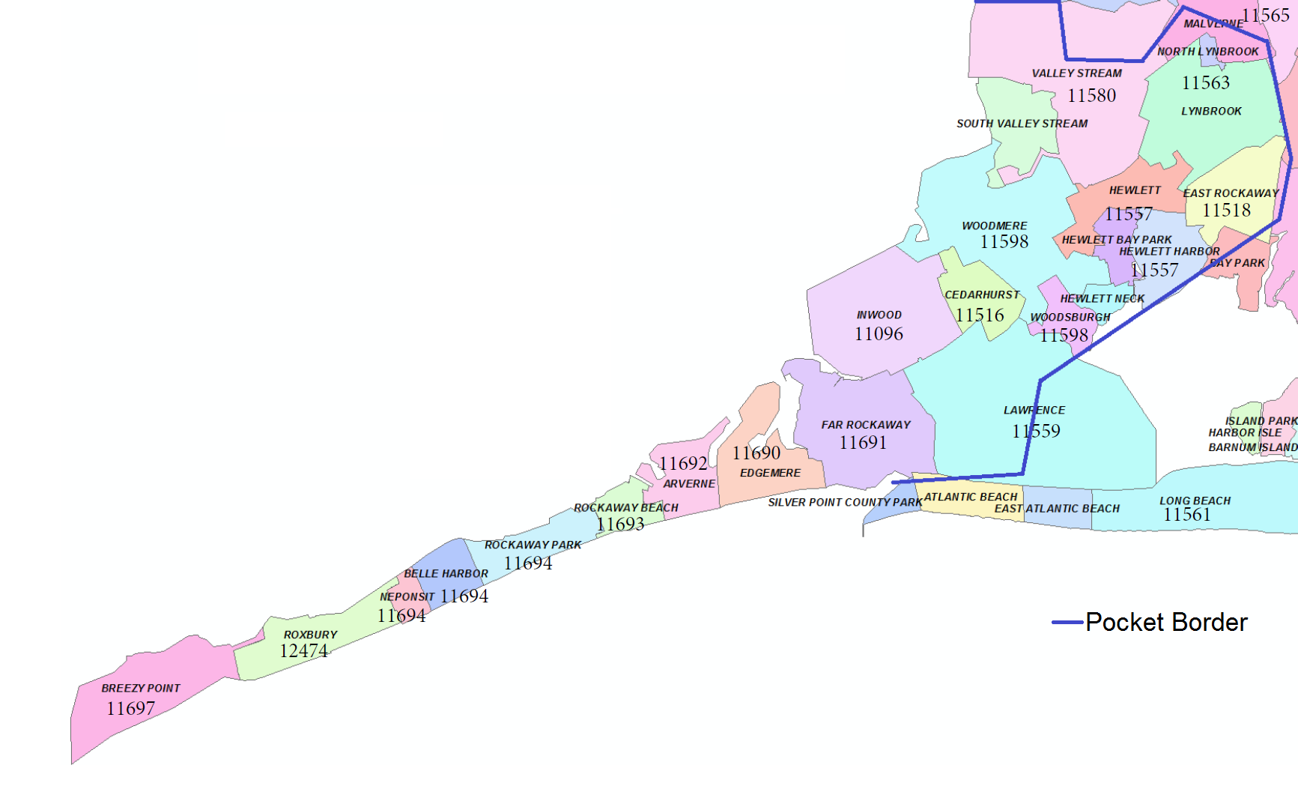

The Load Reduction product and/or service must meet the following criteria:

1. Operating Months must include May 1st through October 31st.
2. Availability Days must include all days of the week.
3. Service Delivery Hours must cover, at a minimum, a 6-hour consecutive period within the 10-hour period between 12:00 PM and 10:00 PM Eastern Prevailing Time (EPT).

The busses in the Far Rockaway and surrounding areas that impact the transmission need are identified in Table A2-1, below. Note that while there is no maximum amount of load reduction resources that can be proposed, there is a required minimum amount of power production resources as identified in Appendix B.

**Table A2-1: Far Rockaway Substations**

|  |  |  |
| --- | --- | --- |
| **Bus Name** | **Transmission Voltage** | **MWs that can be removed at Far Rockaway by reducing 1 MW at the bus** |
| VALLEY STREAM | 138 | 1.875 |
| VALLEY STREAM | 69 | 1 |
| HEWLETT | 69 | 1 |
| WOODMERE | 69 | 1 |
| FAR ROCKAWAY | 69 | 1 |
| ARVERNE | 34.5 | 1 |
| FAR ROCKAWAY | 34.5 | 1 |
| ROCKAWAY BEACH | 34.5 | 1 |
| CEDARHURST | 34.5 | 0.875 |
| MALVERNE | 69 | 0.875 |
| BROADWAY | 34.5 | 0.875 |
| GREEN ACRES | 34.5 | 0.875 |
| LAKEVIEW | 69 | 0.75 |
| LYNBROOK | 34.5 | 0.75 |
| PROSPECT | 34.5 | 0.75 |
| WEST HEMPSTEAD | 69 | 0.625 |
| COUNTRY LIFE PRESS | 69 | 0.5 |
| LONGBCH | 34.5 | 0.125 |
| PARK PLACE | 34.5 | 0.125 |
| GREENFIELD | 34.5 | 0.1 |
| ROOSEVELT | 34.5 | 0.1 |

The non-coincident peaks for the Far Rockaway load area for the preceding 5 years are shown in the Table A2-2 below.

**Table A2-2: Far Rockaway Load Area’s Non-Coincident Peaks**

|  |  |
| --- | --- |
| **Year** | **Total MW** |
|
| 2011 | 232.7 |
| 2012 | 229.2 |
| 2013 | 223.8 |
| 2014 | 194.8 |
| 2015 | 198.0 |

The following Table A2-3 provides peak loads by substation for the Far Rockaway area with the date and time of the peak for the last 5 years. This table accounts for NYISO initiated Demand Response events.

**Table A2-3: Far Rockaway Substation Peak Loads**

|  |  |  |  |  |  |  |  |  |  |  |  |  |  |  |  |  |  |
| --- | --- | --- | --- | --- | --- | --- | --- | --- | --- | --- | --- | --- | --- | --- | --- | --- | --- |
|  | **Far Rockaway** | | **Hewlett** | | **Woodmere** | | **Arverne** | | **Broadway** | | **Cedarhurst** | | **Prospect** | | **Rockaway Beach** | |  |
|  | **2H** | | **2R** | | **2MA** | | **2AR** | | **2BB** | | **2KB** | | **2QB** | | **2G** | | **Total MW** |
|  | PkMW | PeakHour | PkMW | PeakHour | PkMW | PeakHour | PkMW | PeakHour | PkMW | PeakHour | PkMW | PeakHour | PkMW | PeakHour | PkMW | PeakHour |  |
| **2011** | 57.0 | 08/03/11 11A | 34.2 | 07/22/11 3P | 53.8 | 07/22/11 4P | 15.9 | 07/20/11 10A | 10.1 | 07/07/11 1P | 2.9 | 07/22/11 3P | 12.5 | 07/22/11 8P | 46.4 | 07/19/11 10P | **232.7** |
| **2012** | 59.5 | 06/21/12 6P | 41.9 | 06/20/12 5P | 45.6 | 06/21/12 7P | 21.1 | 06/23/12 10P | 4.3 | 06/25/12 7P | 2.9 | 06/21/12 5P | 11.8 | 06/21/12 5P | 42.1 | 07/12/12 10P | **229.2** |
| **2013** | 62.6 | 07/19/13 3P | 41.2 | 07/18/13 3P | 47.5 | 07/19/13 4P | 17.9 | 07/18/13 5P | 4.4 | 07/07/13 5P | 3.1 | 07/18/13 2P | 11.1 | 07/18/13 5P | 36.1 | 07/18/13 5P | **223.8** |
| **2014** | 51.6 | 08/05/14 4P | 36.8 | 08/08/14 4P | 42.0 | 09/02/14 5P | 15.4 | 06/18/14 9P | 3.5 | 09/06/14 4P | 2.7 | 09/02/14 2P | 10.2 | 09/02/14 5P | 32.6 | 09/02/14 9P | **194.8** |
| **2015** | 39.3 | 07/20/15 3P | 40.9 | 09/08/15 2P | 43.1 | 07/20/15 5P | 19.2 | 08/21/15 11A | 3.8 | 09/10/15 11A | 2.7 | 07/29/15 1P | 10.6 | 07/20/15 4P | 38.4 | 06/03/15 11P | **198.0** |

* 1. Customer Characteristics

The type of customers and their contribution to the overall load by classification are displayed in Table A2-4 below.

**Table A2-4: Far Rockaway Electric Usage by Customer Classification**

|  |  |  |
| --- | --- | --- |
| **Customer Class** | **Customers** | **Non-Coincident Peak MW (where available) Oct 2014-Sept 2015** |
| **Residential - Total** | **47,828** | **82.5 MW (Plug**)** |
| *Residential w/ HVAC* | 15,004 (Projected***) | NA |
| *Residential without HVAC* | 32,824  (Projected***) | NA |
| **Non-Residential - Total** | **4,701** | **115.5 (actual)** |
| *Large Commercial & Industrial   ( > 45 MWh annually)* | 1,023 | 100.3 |
| *Small/Medium Commercial & Industrial   ( <= 45 MWh annually)* | 3,678 | 14.5 |
| **Total** | **52,529** | **198** |

**PSEG Long Island does not measure kW loads at Residential customers. The 82.5 MW Residential load is derived using 2015 total peak of 198 MW and then deducting measured/actual loads of 115.5 MW for Non-Residential customers.

***PSEG Long Island uses computer analysis to project the number of residential customers with HVAC.

* + 1. Residential Customers

Residential customers drive approximately 40% of the demand in Far Rockaway. Using an in-house computer program analyzing residential customer usage characteristics, PSEG Long Island concludes that approx. 31% of the residential customers have HVAC units.

The average annual energy usage for residential customers in Far Rockaway is approximately 7,341 kWh. This is compared to the island-wide average annual usage of approximately 9,700 kWh. In addition, using an Island-wide database, PSEG Long Island has extrapolated that approximately 7,173 residential customers in this load area have pool pumps.

It should be noted that some of these residential customers (there is no breakdown by the substation/load area) may already be participating in PSEG Long Island’s existing LIPAEdge program for thermostat control or pool pump controls.

**Figure A2-2: Far Rockaway Residential Customers’ Energy Usage Distribution**

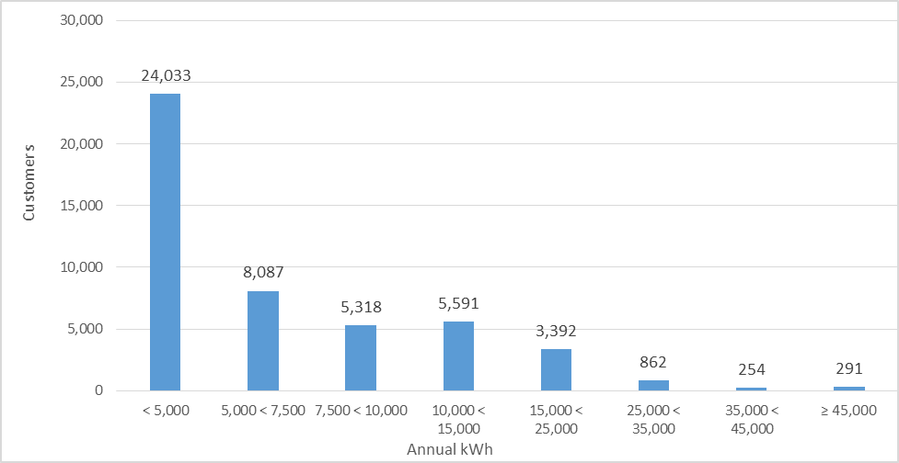

* + 1. Non-Residential Customers

There are 4,701 non-residential customers with 114.8 MW peak demand.

**Table A2-5: Far Rockaway Non-Residential Customers’ Peak Demand Distribution**

|  |  |  |
| --- | --- | --- |
| **Commercial & Industrial Customers (annual kW range)** | **# of Customers** | **MW** |
| 7-15 kW | 3,517 | 8.5 MW |
| 16-30 kW | 560 | 12.3 MW |
| 31-50 kW | 199 | 7.4 MW |
| 51-100 kW | 235 | 16.2 MW |
| 101-250 kW | 101 | 16.7 MW |
| 251-500 kW | 53 | 18.3 MW |
| 501-1000 kW | 23 | 16.1 MW |
| >1000 kW | 13 | 19.3 MW |
| **Total** | **4,701** | **114.8 MW** |

**Figure A2-3: Far Rockaway Non-Residential Customers’ Peak Demand Distribution**

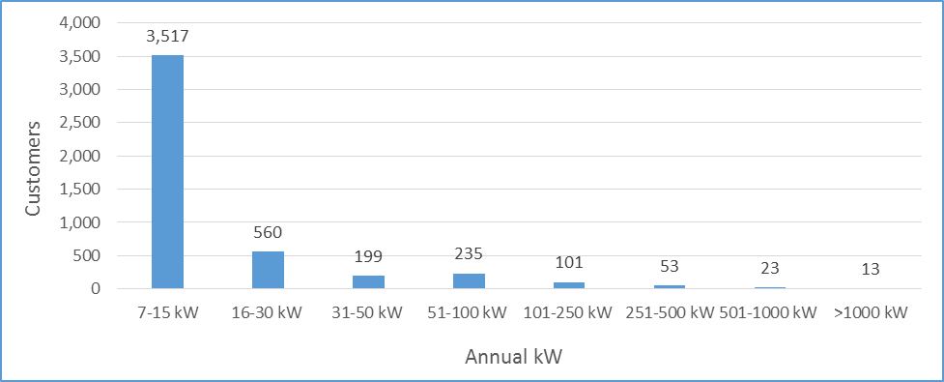

**Figure A2-4: Far Rockaway Non-Residential Customers Breakdown**

**(Rate codes with > 1 MW)**

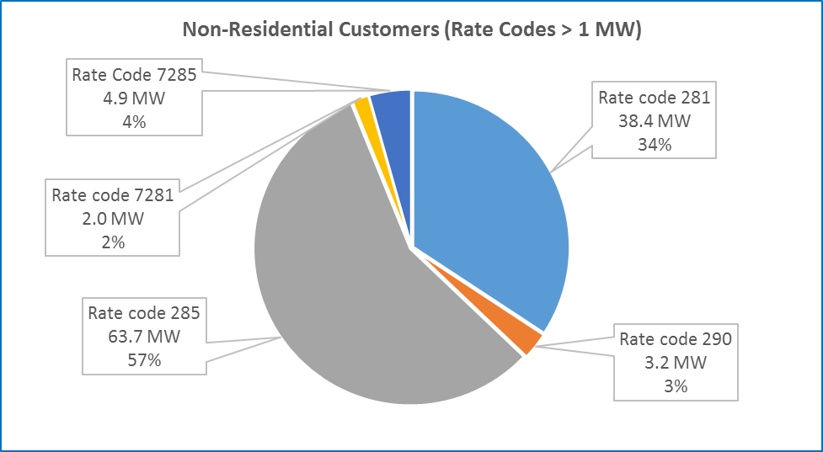

1. Glenwood Load Area

The Glenwood Load Area is shown below in the “zip code” map that delimits the specific potential areas of interest in terms of load reduction.

**Figure A3-1: Glenwood Load Area Zip Code Map**

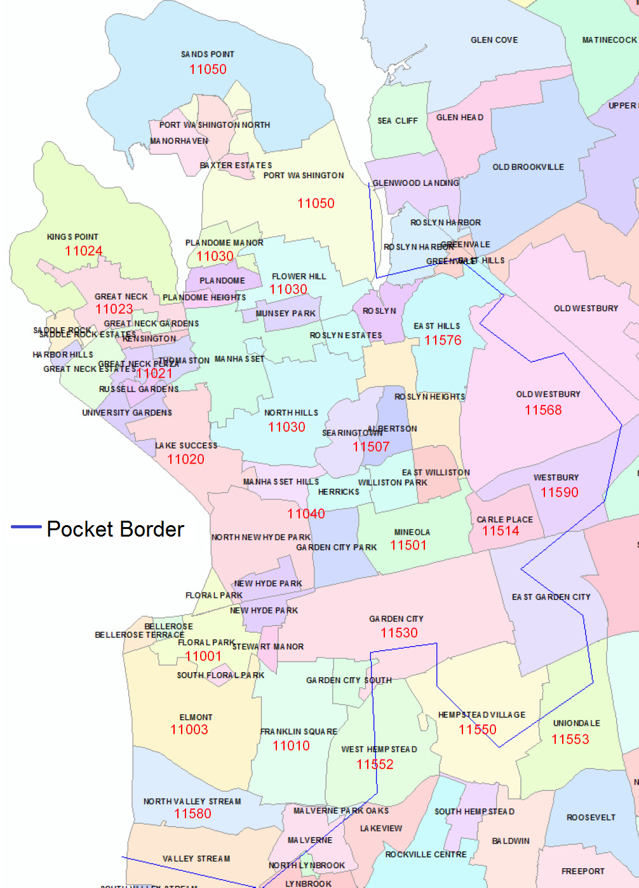

The Load Reduction product and/or service must meet the following criteria:

1. Operating Months must include May 1st through October 31st
2. Load Reduction Availability Days must include all days of the week
3. Service Delivery Hours must cover, at a minimum, a 6-hour consecutive period within the 10-hour period between 12:00 PM and 10:00 PM Eastern Prevailing Time (EPT).

The busses in the Glenwood and surrounding areas that impact the transmission need are identified in Table A3-1, below. Note that while there is no maximum amount of load reduction resources that can be proposed, there is a required minimum amount of power production resources as identified in Appendix B.

**Table A3-1: Glenwood Substations**

|  |  |  |
| --- | --- | --- |
| **Bus Name** | **Transmission Voltage** | **MWs that can be removed at Glenwood by reducing 1 MW at the bus** |
| CARLE PLACE | 138 | 4 |
| LAKE SUCCESS | 69 | 1.25 |
| GREAT NECK | 69 | 1.25 |
| SPERRY | 69 | 1.25 |
| NORTH HILLS | 69 | 1.25 |
| PORT WASHINGTON | 69 | 1 |
| MANHASSET | 69 | 1 |
| BAR BEACH | 69 | 1 |
| GLENHEAD | 69 | 1 |
| ORCHARD | 69 | 0.75 |
| BROOKVILLE | 69 | 0.75 |
| STEWART MANOR | 69 | 0.75 |
| GARDEN CITY PARK | 34.5 | 0.75 |
| NEW CASSEL | 69 | 0.75 |
| HERRICKS | 69 | 0.75 |
| JERICHO | 69 | 0.75 |
| FLORAL PARK | 34.5 | 0.75 |
| LOCUST VALLEY | 69 | 0.5 |
| MITCHELL GARDENS | 69 | 0.5 |
| WHITESDE | 69 | 0.5 |
| ELMONT | 34.5 | 0.5 |
| MEADOWBROOK | 69 | 0.5 |
| CENTRAL AVE | 34.5 | 0.25 |
| OYSTERBAY | 69 | 0.25 |
| CORONA | 69 | 0.25 |

The non-coincident peaks for the Glenwood load area for the preceding 5 years are shown in the Table A3-2 below.

**Table A3-2: Glenwood Load Area’s Non-Coincident Peaks**

|  |  |
| --- | --- |
| **Year** | **Total MW** |
|
| 2011 | 810.6 |
| 2012 | 729.1 |
| 2013 | 747.5 |
| 2014 | 665.4 |
| 2015 | 713.9 |

The following Table A3-3 provides peak loads by substation for the Glenwood area with the date and time of the peak for the last 5 years. This table accounts for NYISO initiated Demand Response events.

**Table A3-3: Glenwood Load Area Substation Peak Loads**

|  |  |  |  |  |  |  |  |  |  |  |  |  |  |  |  |  |  |  |  |  |
| --- | --- | --- | --- | --- | --- | --- | --- | --- | --- | --- | --- | --- | --- | --- | --- | --- | --- | --- | --- | --- |
|  | **Corona Avenue** | | **Great Neck** | | **Herricks** | | **Manhasset** | | **North Hills** | | **Port Washington** | | **Whiteside** | | **Bar Beach** | | **Stewart Manor** | | **Central Avenue** | |
|  | **2AB** | | **3A** | | **3KG** | | **3D** | | **3LG** | | **3H** | | **3J** | | **4X** | | **4S** | | **2W** | |
|  | PkMW | PeakHour | PkMW | PeakHour | PkMW | PeakHour | PkMW | PeakHour | PkMW | PeakHour | PkMW | PeakHour | PkMW | PeakHour | PkMW | PeakHour | PkMW | PeakHour | PkMW | PeakHour |
| **2011** | 51.6 | 07/22/11 7P | 96.8 | 07/22/11 3P | 48.7 | 07/22/11 7P | 49.8 | 07/22/11 5P | 50.8 | 07/21/11 2P | 56.5 | 07/26/11 5P | 82.2 | 07/23/11 4P | 36.2 | 07/26/11 4P | 6.9 | 06/11/11 1A | 8.9 | 07/22/11 10P |
| **2012** | 45.2 | 06/21/12 6P | 85.5 | 06/21/12 6P | 42.3 | 06/21/12 5P | 45.9 | 06/21/12 5P | 46.1 | 06/21/12 5P | 48.1 | 06/21/12 5P | 75.9 | 06/21/12 7P | 31.4 | 06/21/12 4P | 7.8 | 06/21/12 10P | 8.3 | 06/21/12 10P |
| **2013** | 51.4 | 07/19/13 6P | 92.9 | 07/18/13 6P | 40.6 | 09/11/13 4P | 40.8 | 07/18/13 5P | 33.6 | 07/11/13 6P | 54.6 | 07/18/13 9P | 79.4 | 07/19/13 6P | 35.2 | 07/18/13 5P | 8.1 | 07/18/13 8P | 8.6 | 07/18/13 10P |
| **2014** | 41.7 | 09/02/14 9P | 78.3 | 09/02/14 5P | 38.8 | 07/08/14 6P | 35.4 | 09/02/14 5P | 40.5 | 09/02/14 5P | 43.5 | 09/02/14 5P | 73.1 | 07/03/14 6P | 28.4 | 09/02/14 5P | 6.9 | 09/02/14 9P | 7.2 | 09/02/14 9P |
| **2015** | 46.1 | 07/20/15 6P | 93.7 | 07/20/15 8P | 45.1 | 07/29/15 4P | 36.2 | 07/20/15 3P | 40.9 | 07/20/15 2P | 48.0 | 08/25/15 4P | 68.2 | 06/23/15 6P | 32.5 | 07/20/15 3P | 7.3 | 06/23/15 2P | 7.8 | 06/01/15 9P |

|  |  |  |  |  |  |  |  |  |  |  |  |  |  |  |  |  |
| --- | --- | --- | --- | --- | --- | --- | --- | --- | --- | --- | --- | --- | --- | --- | --- | --- |
| **Elmont** | | **Floral Park** | | **Garden City Park** | | **Hempstead** | | **Carle Place** | | **Roslyn** | | **Lake Success** | | **East Garden City** | |  |
| **3G** | | **3B** | | **3W** | | **4K** | | **4AH** | | **4B** | | **3AG** | | **4H** | | **Total MW** |
| PkMW | PeakHour | PkMW | PeakHour | PkMW | PeakHour | PkMW | PeakHour | PkMW | PeakHour | PkMW | PeakHour | PkMW | PeakHour | PkMW | PeakHour |
| 4.0 | 07/22/11 10P | 7.0 | 06/01/11 5P | 2.0 | 07/22/11 2P | 6.9 | 08/26/11 9P | 85.3 | 07/22/11 4P | 64.3 | 07/22/11 3P | 63.6 | 07/22/11 5P | 89.1 | 07/23/11 9P | **810.6** |
| 3.6 | 07/07/12 3P | 6.4 | 06/20/12 9P | 3.3 | 08/02/12 4P | 8.3 | 06/21/12 7P | 77.7 | 07/18/12 2P | 49.3 | 06/21/12 5P | 57.0 | 06/21/12 5P | 87.0 | 07/18/12 2P | **729.1** |
| 3.9 | 07/19/13 7P | 6.5 | 07/19/13 9P | 3.9 | 07/19/13 1P | 9.2 | 07/18/13 7P | 78.2 | 07/19/13 5P | 51.9 | 07/19/13 5P | 58.6 | 07/19/13 5P | 90.1 | 06/24/13 1P | **747.5** |
| 3.3 | 09/02/14 9P | 5.4 | 09/02/14 8P | 3.2 | 09/02/14 5P | 6.6 | 07/02/14 8P | 74.0 | 09/02/14 5P | 45.0 | 09/02/14 5P | 51.4 | 09/02/14 5P | 82.6 | 09/02/14 5P | **665.4** |
| 4.5 | 07/29/15 8P | 9.1 | 06/23/15 3P | 3.6 | 07/29/15 2P | 6.5 | 07/20/15 9P | 78.1 | 07/29/15 1P | 48.6 | 07/29/15 4P | 53.0 | 09/08/15 4P | 84.7 | 08/25/15 3P | **713.9** |

* 1. Customer Characteristics

The type of customers and their contribution to the overall load by classification are displayed in Table A2-6 below.

**Table A3-4: Glenwood Electric Usage by Customer Classification**

|  |  |  |
| --- | --- | --- |
| **Customer Class** | **Customers** | **Non-Coincident Peak MW (where available) Oct 2014-Sept 2015** |
| **Residential - Total** | **120,769** | **273.9 (Plug**)** |
| *Residential w/ HVAC* | 32,883  (projected***) | NA |
| *Residential without HVAC* | 87,886  (projected***) | NA |
| **Non-Residential - Total** | **14,933** | **440 (actual)** |
| *Large Commercial & Industrial   ( > 45 MWh annually)* | 3,685 | 387 |
| *Small/Medium Commercial & Industrial   ( <= 45 MWh annually)* | 11,248 | 53 |
| **Total** | **135,702** | **713.9** |

**PSEG Long Island does not measure kW loads for Residential customers. The 273.9 MW Residential load is derived using 2015 total peak of 713.9 MW and then deducting measured/actual loads of 440 MW for Non-Residential customers.

***PSEG Long Island uses computer analysis to project the number of residential customers with HVAC.

* + 1. Residential Customers

Residential customers drive approximately 45% of the demand in Glenwood load area. Using an in-house computer program analyzing residential customer usage characteristics, PSEG Long Island concludes that approx. 28% of the residential customers have HVAC units.

The average annual energy usage for residential customers in Glenwood is approximately 9,249 kWh, compared to the island-wide average annual usage of around 9,700 kWh. Using an Island-wide database, PSEG Long Island estimates that the number of residential customers with pool pumps is 24,154 (20%).

It should be noted that some of these residential customers (there is no breakdown by the substation/load area) may already be participating in PSEG Long Island’s existing LIPA Edge program for thermostat control or pool pump controls.

**Figure A3-2: Glenwood Residential Customers’ Energy Usage Distribution**

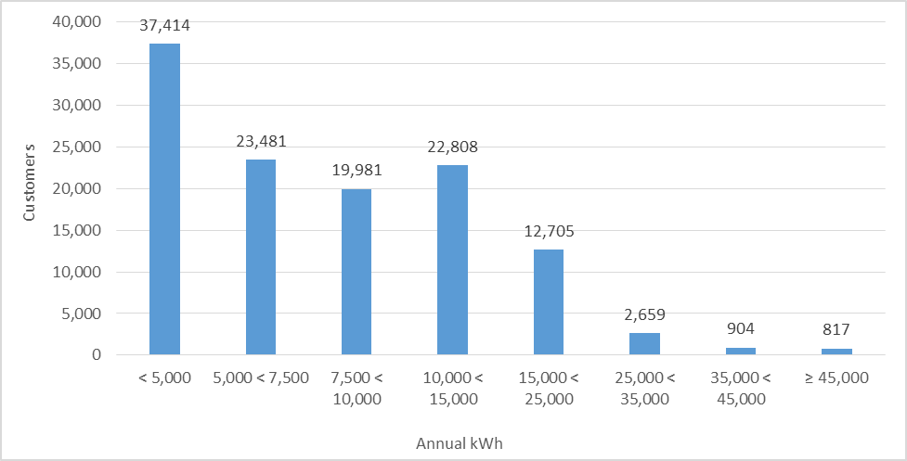

* + 1. Non-Residential Customers

There are 14,933 non-residential customers with 440 MW peak demand.

**Table A3-5: Glenwood Non-Residential Customers’ Peak Demand Distribution**

|  |  |  |
| --- | --- | --- |
| **Commercial & Industrial Customers**  **(annual kW range)** | **# of Customers** | **MW** |
| 7-15 kW | 10,429 | 31.7 MW |
| 16-30 kW | 2,073 | 45.3 MW |
| 31-50 kW | 826 | 30.9 MW |
| 51-100 kW | 878 | 60.5 MW |
| 101-250 kW | 435 | 69.5 MW |
| 251-500 kW | 162 | 58.2 MW |
| 501-1000 kW | 80 | 56.3 MW |
| >1000 kW | 50 | 87.6 MW |
| **Total** | **14,933** | **440.1 MW** |

**Figure A3-3: Glenwood Non-Residential Customers’ Peak Demand Distribution**

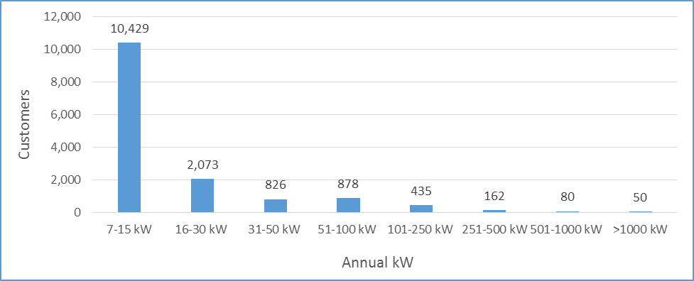

**Figure A3-4: Glenwood Non-Residential Customers Breakdown**

**(Rate codes with > 1 MW)**

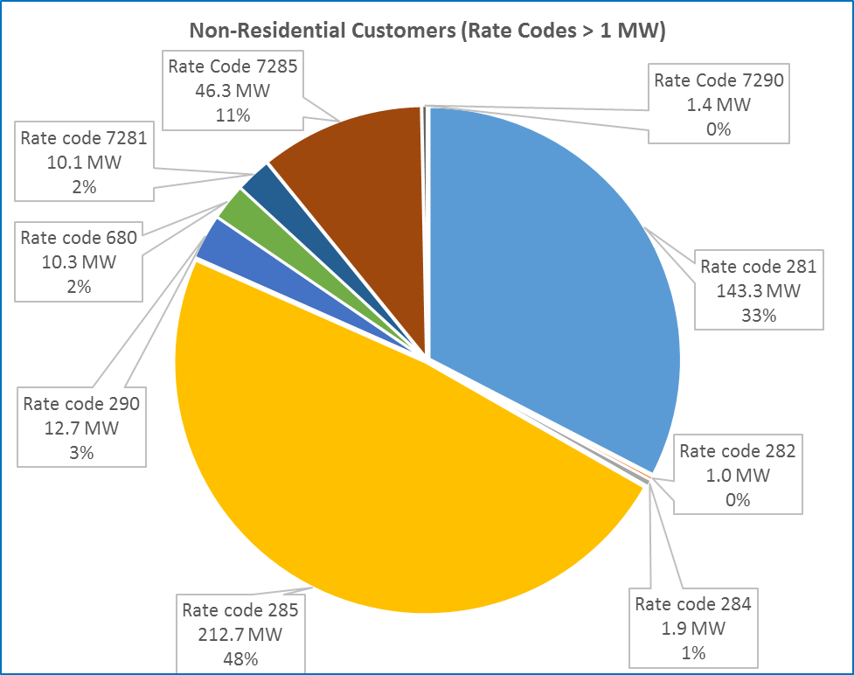

1. ROLES AND RESPONSIBILITIES (AS APPLICABLE)
   1. PSEG Long Island Responsibilities
2. PSEG Long Island shall be responsible for the overall management of the electric distribution system within its service territory. PSEG Long Island shall provide oversight of the Program.
3. PSEG Long Island shall be responsible for managing the contract with the Respondent, who shall be fully responsible for the delivery of the Program. PSEG Long Island shall monitor all program activity, review major decisions, and assess and evaluate the Respondent’s compliance in accordance with performance expectations and requirements.
4. All databases developed from Program information shall become the property of LIPA. The Respondent shall be obligated to provide PSEG Long Island with copies of such databases in the format approved by PSEG Long Island. PSEG Long Island may contract with an independent evaluator to evaluate the Program in accordance with the contract.
5. PSEG Long Island may conduct independent QA inspections of Services performed within the Program. The Respondents is expected to provide any required information and/or documentation in a timely manner to facilitate and/or fulfill this inspection function. PSEG Long Island may conduct continuous reviews throughout the Program to monitor performance metrics.
6. PSEG Long Island may perform independent measurement, verification and evaluation of reported impacts and savings provided by Respondent(s).
7. While not guaranteed, PSEG Long Island anticipates that it will provide a single point interface software platform, which all Respondent(s) will need to integrate their respective communications, data flows, billing determinants, and command/control system utility grid interfaces through the Distributed Energy Resource Platform (the “DER Platform”). PSEG Long Island, in the case of Load Reduction events, shall dispatch the load control event with sixty (60) minutes of notice, when possible. In the case of system disturbances, PSEG Long Island shall dispatch the load control event with 10 minutes of notice.
8. PSEG Long Island shall partner with the Respondent(s) in handling escalated customer complaints.
9. PSEG Long Island shall have final approval on all Program materials (if applicable). PSEG Long Island shall review all marketing campaigns of the Respondent(s) for adherence to PSEG Long Island standards.
10. PSEG Long Island shall provide Respondent with requested utility metering and devices in accordance with its standard tariffs and/or fees and in the course of its general utility practices.
11. PSEG Long Island shall pay Respondent for services rendered subject to contractual terms and/or rules and requirements being met.
    1. Respondent Responsibilities
12. Respondent shall be responsible for the provision of the two-way communication and Load Reduction technology. Respondent’s communication technology should be capable of interfacing with and supporting the planned PSEG Long Island DER Platform and should be based upon open ADR protocols.
13. Respondent shall be responsible for developing an Implementation Plan governing the Program operations for PSEG Long Island’s review, which is to be delivered within ninety (90) days after an executed contract to provide services for the Program. The Respondent shall provide ongoing, day-to-day delivery and implementation of the Program.
14. Respondent shall be responsible for tracking participant data necessary to measure load reductions during peak reduction events and to evaluate the Program in a form that can be uploaded to a centralized database and/or event notification system. Respondent must discuss the expected results and savings of the Program by year, over the contract period, and the recommended market indicators and metrics to be employed to forecast activity levels and results.
15. Respondent shall be responsible for supporting the data and informational requirements necessary to perform any independent measurement, verification and/or evaluation by PSEG Long Island.
16. Respondent shall be responsible for providing a quality assurance and quality control (QA/QC) plan that describes how it shall ensure the accuracy and reliability of the delivered services. The QA/QC plan shall also describe how it will ensure the Program meets PSEG Long Island’s quality standards. Respondent must be prepared to adhere to standards of customer service and QA/QC, which equal or exceed industry norms.
17. Respondent shall be responsible to provide a description of important quality assurance issues and standards, including how load reductions will be regularly monitored, and reporting, tracking and report generation expectations will be met.
18. Respondent shall be responsible to schedule formal production meetings with PSEG Long Island as often as needed to discuss overall program progress, review marketing and sales activities (if applicable), review savings and budget forecasts, review vendor activity reports and invoices, and identify and resolve program issues and develop action plans.
19. Respondent shall be responsible for providing PSEG Long Island with remote access to its entire Program related sales and operations tracking and reporting databases.
20. Respondent shall be responsible for identifying key program data, decision points and the process it will use to generate reports that fully capture program activity relative to target milestones and goals.
21. Respondent shall discuss its data security and integrity in its proposal.
22. Respondent shall be responsible for describing their administrative and technical capabilities to manage all of the administrative and implementation functions associated with delivery, tracking, and reporting on the Program.
23. Respondent shall provide a full marketing plan and timeline, including optional contingency mechanisms and levers to boost enrollment as needed.
24. Respondent shall coordinate with the utility marketing team to allow review of all marketing campaigns for compliance to PSEG Long Island’s standards and requirements.
25. Respondent shall perform all activities associated with maintaining a call center operation including, but not limited to, customer recruitment, handling all types of enrollments, installation scheduling, service call processing, complaint handling and tracking, as well as warm transfer between PSEG Long Island’s and Respondent’s call center.
26. Respondent shall perform all necessary and appropriate Commissioning Tests prior to COD to ensure that the Program functions as intended.
27. PERFORMANCE (AS APPLICABLE)

PSEG Long Island and the Respondent will negotiate the specific performance goals and associated penalties at the time of contract negotiations. Respondents are encouraged to propose specific performance goals and associated penalties for non-performance and failure to meet the performance metrics.

* 1. Performance Metrics

PSEG Long Island shall develop a Scorecard that will measure contract performance based on key contract metrics. A quarterly Metric Review Meeting shall be required, at which time the Scorecard shall be reviewed with the Respondent. The responsible PSEG Long Island Program Manager and Procurement Specialist will also be in attendance. Performance metrics shall include the following:

1. Safety – Consistent with current PSEG Long Island targets
2. Reporting – Timely and accurate
3. Invoicing – Timely and accurate
4. Customer Satisfaction
5. Energy and Demand Savings –Meeting goals
   1. Penalties for Callable Resources
6. Penalty rates shall be applied to any deficit of contracted capacity relief based upon the difference between the customer’s Customer Baseline Load (CBL) assigned to each hour of the event period and its metered use in that hour.
7. The CBL shall be calculated using 5 out of 10 days, where a customer’s past usage is reviewed within a specified time window (up to 8 hours between the hours of 1:00 – 9:00 pm). Data is collected for 10 days and 5 of those days are used for the calculation. CBL is defined as the high 5 out of 10 days. The last 10 similar days are collected and then the lowest 5 load days of those 10 are dropped. That will leave the highest 5 out of the last 10 similar days for calculations.
8. At PSEG Long Island’s discretion, Load Reduction tests may be conducted prior to the beginning of the season to verify that the Respondent can meet the contracted load commitment.
   1. Penalties for Distributed Generation Resources
9. Penalty rates shall be applied to any deficit of contracted capacity relief/delivery based upon metered data for each hour of the event period.
10. VOLTAGE RIDE-THROUGH CAPABILITY (AS APPLICABLE)
11. Any load reduction achieved using photovoltaic (PV) generation or electrical energy storage shall use inverters that have voltage ride-through capabilities compliant with California Public Utility Commission Electric Tariff Rule 21, Section Hh.2.b(ii), Table Hh.1, Section Hh.2.f(i), and Table Hh.2. Inverters shall be tested and certified by Underwriter’s Laboratory for compliance with these requirements.

# Appendix B: POWER PRODUCTION SPECIFICATIONS & OTHer

1. POWER PRODUCTION RESOURCES

This RFP anticipates that Power Production resources will comprise of one or more of the following:

1. Conventional generating units, without any other major power-producing component, using a fuel-based prime mover coupled to a synchronous generator.
2. Generating units, other than as described in Section B.1(a), above, (e.g., a resource that produces direct current and is interconnected to the T&D System via an inverter). Proposals including additional or alternative technologies will be considered.
3. Electrical energy storage devices, interconnected to the T&D System via converters.

These will be evaluated against the objectives of the 2016 WN RFP by adaptation of the specifications contained herein to the particular characteristics of the alternative technology proposed.

Transmission maps of the Western Nassau Area (i.e., Far Rockaway, Glenwood) will be provided upon request. Completion of a LIPA non-disclosure agreement (“NDA”) and a Critical Energy Infrastructure Information (“CEII”) NDA are required.

1. APPLICABLE RULES AND STANDARDS
   1. NYISO and LIPA Interconnection Rules

All proposed facilities must adhere to the NYISO’s Large Generator and Small Generator Interconnection Procedures. Respondents are encouraged to seek information about potential interconnection points in accordance with LIPA’s interconnection procedures, which are available on the RFP website. Additional information was provided in section 2.4 of the RFP. For further information on interconnection requirements, Respondents should contact Steve Cantore of PSEG Long Island’s Power Asset Management Department, Phone (516) 949-8295, E-mail: Stephen.Cantore@PSEG.COM.

* 1. NPCC Standards

All devices (including generators and storage hardware) that produce power must meet the requirements of NPCC Reliability Reference Directory #12, Under-frequency Load Shedding Program Requirements, including Figure 1 (Standards for setting under frequency trip protection for generators).

1. System Dispatch and Bidding

PSEG Energy Resources and Trade (ER&T) will bid Power Production resources into the NYISO. Respondent shall provide all information required to allow PSEG ER&T to bid the plant and must agree to provide all information required by the NYISO. Respondent shall operate the plant in a manner that complies with NYISO rules and requirements.

1. Locational Requirements and Information
   1. Storm-Resistant Location and Facilities

Power Production resources and interconnection facilities must be designed to withstand 130 mph winds and to elevate equipment to accommodate updated 1-in-500 year flood zones.

* 1. Site Control

Power Production resources shall be located on sites controlled by Respondent through either fee ownership, land leases, options to lease or purchase, or equivalent demonstration of site control. Respondent shall provide evidence of such site control or its plan to obtain site control in its proposal. All Respondents are responsible for seeking such site control from third parties.

* 1. Resource Interconnection Point

Power Production resources shall be interconnected to the transmission System at the Far Rockaway 69 kV bus for the Far Rockaway Load Area, or at the Glenwood 69 kV north bus for the Glenwood Load Area (i.e., Points of Interconnection). There is only one terminal available for the interconnection at each location.

* 1. Fuel Supply

Where applicable, Proposals shall include all fuel-related delivery and storage infrastructure. For electrical energy storage devices, Respondents shall provide all electrical interconnection infrastructure required for power production and charging according to Section 3.2.9.3. Respondents may rely upon LIPA to procure electricity for charging storage devices.

* 1. Environmental Conditions

The environmental conditions used for design and performance calculations shall be within the boundaries listed in Table B4-1.

**Table B4-1: Assumed Environmental Conditions**

|  |  |
| --- | --- |
| **Environmental Conditions** | |
| **Category** | **Requirements** |
| Maximum ambient dry-bulb temperature | 105 degree-F |
| Maximum ambient wet-bulb temperature | 80 degree-F |
| Minimum ambient air temperature | -20 degree-F |
| Maximum daily average ambient air temperature | 90 degree-F |
| Minimum daily average ambient air temperature | 10 degree-F |
| Maximum relative humidity | 100 % |
| Minimum relative humidity | 10 % |
| Average annual rain fall | 45 inch |
| Extreme rain fall | 3 in/hr |
| Ice loading conditions | ¾ inch |
| Maximum ground snow depth | 24 inch |
| Maximum frost depth | 3 feet |
| Maximum steady wind velocity  (NESC Heavy) | 130 mph (165 mph 3 second gusts) |
| Flood Preparation (Design) | Ability to withstand one (1) in five hundred (500) years Flood Zone concerns |
| Keraunic level  (number of thunderstorm days per year) | 30 days/year |
| Contamination level | SALT LADEN Atmosphere within 1000 Feet of ocean and seaways  (HEAVY per IEEE C57-19-100, Section 9.1.1 Table 1) |
| Seismic Data | New York State Building Code ***Z*** = 0.18  (The ***Z*** numerically corresponds to effective peak acceleration in g on rock/stiff soil S1 conditions - shear wave velocities of about 2,500 ft./sec. |

1. Electrical System Characteristics

The following describes the system electrical characteristics at the Far Rockaway Point and Glenwood Points of Interconnection.

* 1. Existing Short-Circuit Current

The existing short-circuit current capacities at the Far Rockaway and Glenwood 69 kV busses (i.e., default Points of Interconnection) are provided in Table B.5-1. Ultimate short-circuit capacity is the value to be used for substation design, switchgear rating, and calculations to withstand short-circuit events. Maximum capacity is the short-circuit level in the present system with all generation on Long Island in service. Minimum short-circuit capacities are the lowest level to be normally encountered, without any lines or transformers out of service. Minimum contingency level is the most severe line outage condition for which the Power Production resources are required to remain in unrestricted operation, while synchronized with the T&D System.

**Table B.5-1: Short-Circuit Current Capacities at the Points of Interconnection**

|  |  |  |  |  |
| --- | --- | --- | --- | --- |
|  | **Far Rockaway 69kV Bus** | | **Glenwood 69kV North Bus** | |
| **3-Phase** | **1-Phase** | **3-Phase** | **1-Phase** |
| Ultimate | 43 kA | | 43 kA | |
| Maximum | 21.39 kA | 22.97 kA | 35.81 kA | 26.14 kA |
| Minimum | 15.47 kA | 18.03 kA | 25.30 kA | 21.75 kA |
| Minimum contingency | 7.85 kA | 10.00 kA | 18.35 kA | 17.88 kA |

* 1. Steady-State Electrical Characteristics

The steady-state (continuous) electrical characteristics of the T&D System are specified in Table B.5-2. Voltages are specified in per unit and percent of the nominal 69 kV voltage, respectively. Power Production resources shall operate without restriction over these ranges.

**Table B.5-2: Transmission System Steady-State Characteristics**

|  |  |  |
| --- | --- | --- |
| **System Parameters** | | **Values** |
| Continuous ac system voltage range | | 0.95-1.05 p.u. |
| Maximum negative-sequence voltage component | | 2 % of nominal voltage |
| Maximum zero-sequence voltage component | | 1 % of nominal voltage |
| Ambient voltage distortion | 2nd harmonic | 1.0% |
| 3rd harmonic | 0.6% |
| 4th harmonic | 0.6% |
| 5th harmonic | 3.5% |
| 7th harmonic | 2.0% |
| 6th, 8th, 9th, 10th 12th harmonic | 0.3% |
| 11th, 13th harmonic | 0.5% |
| Harmonics n > 13 | 0.2% |
| Total Harmonic Distortion | 4.0% |
| Nominal frequency | | 60.0 Hz |
| Normal system frequency range | | 59.95 – 60.05 Hz |

* 1. Temporary Voltages and Frequencies

System disturbances can cause the voltage and frequency of the T&D System to go outside the steady-state ranges specified in Table B.5-2. For the temporary operating conditions specified in Table B.5-3, Power Production resources shall be designed to withstand these conditions without damage or loss of availability, and shall remain functional.

**Table B.5-3: Transmission System Temporary Conditions**

|  |  |
| --- | --- |
| **System Parameters** | **Values** |
| Temporary voltage range, up to four hour duration (positive sequence component) | 0.90 to 1.10 p.u. of nominal voltage |
| Short-term voltage range (positive sequence component) | (See Figure B.5-1) |
| Maximum short-term negative sequence | (See Figure B.5-2) |
| Temporary frequency excursions | (See Figure B.5-3) |
| Maximum rate of change for frequency – df/dt | 0.25 Hz per second |

**Figure B.5-1: Short-Term Positive Sequence Voltage Range**

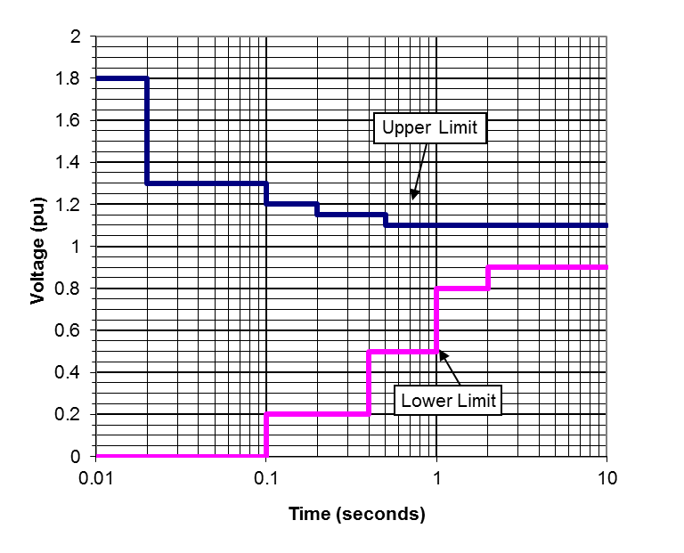

**Figure B.5-2: Maximum Short-Term Negative Sequence Voltage Component**

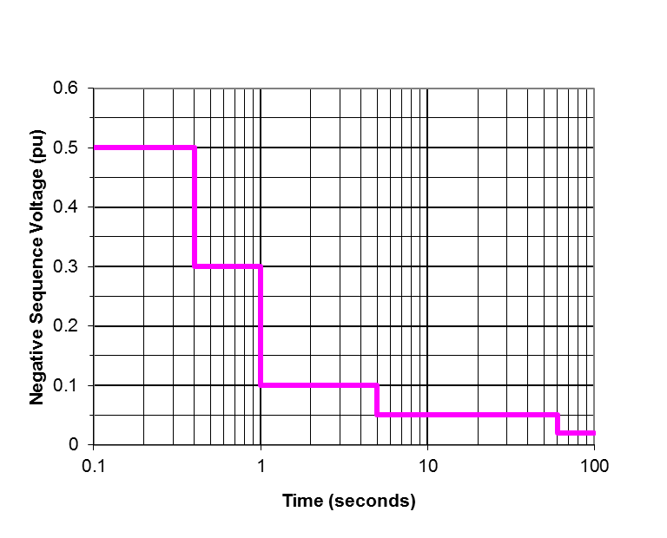

**Figure B.5-3: Maximum Temporary Frequency Deviation**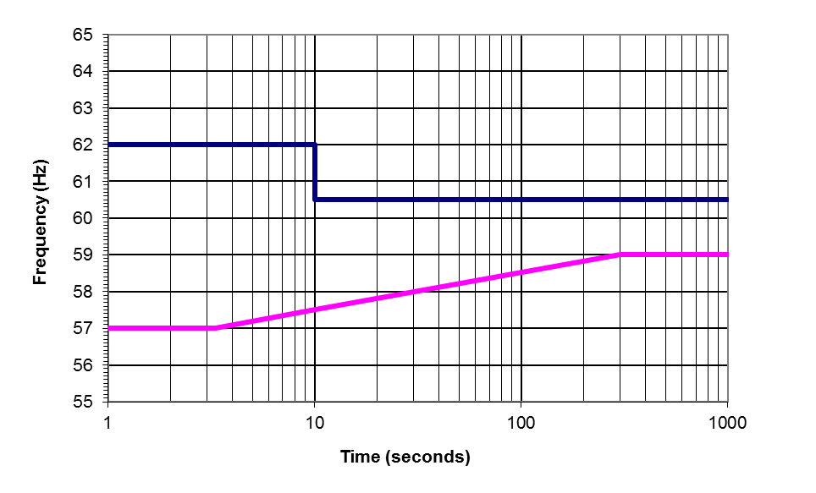

* 1. Fault Clearing Times

The fault clearing times for the 69 kV transmission systems in the Far Rockaway and Glenwood Load Areas are provided in Table B.5-4. The primary clearing time is the sum of the time required for relay reaction to the initial fault condition and the local breaker clearing time. The backup clearing time is the duration of the primary relay breaker failure timer and the backup breaker clearing time.

**Table B.5-4: Far Rockaway & Glenwood Load Areas**

**Transmission System Fault Clearing** **and Reclose Delay Times**

|  |  |
| --- | --- |
| **Voltage Level** | **69 kV** |
| Primary clearing | 7 cycles |
| Backup clearing | 22 cycles |
| Reclose delay | 0.5 to 2.0 seconds |

* 1. Existing Transmission-Connected Power Electronic Systems

Certain large power electronic conversion based facilities are connected to the LIPA T&D System. Of these facilities, the Neptune RTS HVDC Transmission System, located in Nassau County, has controls that pose a potential for interaction with the proposed Power Production resource. A summary description of this facility is provided below.

The 660 MW merchant-operated Neptune RTS HVDC system is terminated on Long Island at the Duffy Avenue Converter Station, which is interconnected through a dedicated 345 kV ac cable and two autotransformers to the LIPA system at the Newbridge Road 138 kV substation. The Duffy Ave converter station has five harmonic filter / shunt capacitor banks of approximately 105 MVAR rating per bank. AC filter dispatch is a function of power transfer, and different allowable filter combinations are possible. One 115 MVAR shunt reactor is also connected. The Duffy Avenue converter station also has active harmonic filters. This HVDC system will normally operate in reactive interchange control mode, but may also operate to regulate the Newbridge Road 138 kV bus voltage. Overvoltages and undervoltages caused by disturbances of the HVDC system, including commutation failures and load rejection, can be expected to affect voltages on the LIPA 138 KV transmission system. With a minimum system short circuit capacity, the maximum AC voltage change at the Newbridge Road 138kV bus for switching a single filter capacitor bank is estimated at 2.0%. The maximum MW ramp rate is estimated as a power transfer level change of 660 MW in ten minutes.

1. Resource Capacity and Dispatch Response
   1. Site Continuous Power Capacity

Capacity is needed at each of the two Power Production areas. A Power Production resource, or resources, shall have a net effective power capacity, measured at the Point of Interconnection, within the ranges, as appropriate, specified in Sections 1.4.1 and 1.4.2. If the resource is inherently variable (non dispatchable) then effective power capacity is the 95th percentile probability of available power output during the stated time periods. The following conditions must be met by the Power Production resource Proposals:

1. At Far Rockaway 69kV bus, the minimum effective capacity at the site shall be 275 MW in 2030. Section 1.4.1 depicts the preliminary estimates of the transmission reinforcements that are required for various output levels. As an alternative, the minimum effective capacity can be reduced to no less than 240 MW if a minimum 35 MW of equivalent load reduction is also proposed. The yearly requirement in section 1.4.1/table 1.1 shows the minimum power production resource for each year starting from 2020, assuming the remaining requirement is provided by load reduction. Load tables and available busses for reduction along with its relationship to Far Rockaway generation can be found in appendix A, section A2.
2. The load reduction resource in the Far Rockaway area shall be available as specified in Appendix A2, without recharging of any manner from the power system during the required service delivery hours. The energy requirement of the load reduction resource is equal to the peak demand reduction multiplied by the required duration and multiplied by 80%. The power production resource of 240 MW must be available all hours and all days in a year without any limitations to specific hours in a day.
3. At Glenwood 69kV north bus, the minimum effective capacity at the site shall be 100 MW in 2030. As an alternative, the minimum effective capacity can be reduced to no less than 75 MW if a minimum 25 MW of equivalent load reduction is also proposed. Load tables and available busses for reduction along with its relationship to Glenwood generation can be found in appendix A, section A3.
4. The load reduction resource in the Glenwood area shall be available as specified in Appendix A2, without recharging of any manner from the power system during the required service delivery hours. The energy requirement of the load reduction resource is equal to the peak demand reduction multiplied by the required duration and multiplied by 80%. The power production resource of 75 MW must be available all hours and all days in a year without any limitations to specific hours in a day.

Batteries/energy storage are acceptable responses to this RFP. Energy storage may be proposed as a peak shaving device under the load reduction application (Appendix A). For energy storage as a power producing source, it does need to comply with these technical requirements to support the PSEG Long Island system and criteria. Energy storage can also be a viable power production solution if coupled with another technology or contains a recharging source and meets the availability requirements. Energy storage must be able to supply energy for an undetermined amount of time.

For Power Production resources using fuel-based generation, the Respondent’s fuel storage and fuel delivery logistics plans shall be based on supplying the amount of energy proposed.

These power capacity requirements apply when the voltage and frequency at the Points of Interconnection are within the normal ranges specified in Table B.5-2. At voltage levels less than 0.95 p.u. of nominal, each Power Production resource shall be capable of delivering real current (current in phase with the voltage) equal to the real current required to deliver rated power at 0.95 p.u voltage.

* 1. Power Dispatch Response

Power Production resources must be able to respond to dispatch orders to any power level greater than or equal to the stated minimum Power Production load level and up to an including the stated Power Production capacity.

* + 1. Applicable Period

The requirement to be available to follow a dispatch order in the event of a transmission contingency in the area shall only apply during hours when the load in the area is greater than the level at which the transmission system can support the next contingency without causing any thermal constraints. The resource may be subject to dispatch at any other times for system reliability, economic, or other reasons determined to be necessary by PSEG-LI System Operations or the NYISO, subject to the resource’s availability.

For Far Rockaway, the estimated number of hours per year where the load level is such that the system is exposed to N-1-1 constraints are 129 hours in 2020 to 401 hours in 2030.

For Glenwood, the estimated number of hours per year where the load level is such that the system is exposed to N-1-1 constraints are 7 hours in 2020 to 29 hours in 2030.

The exposure hours mentioned above assume all other system resources are in service. It is likely that these power production resources may get called upon to support the system needs based on the system conditions.

* + 1. Dispatch Response Time

The Power Production resource shall achieve the dispatched power level within 30 minutes of receiving a dispatch order in any period.

The dispatch response time may be met by either:

1. Preemptively synchronized and in operation running at all times during the applicable period, as defined in B.6.2.1, at a power level such that the resource can ramp to an output at least as great as the secure dispatch level in the event of an N-1 transmission contingency. Proposals for this mode of operation shall be evaluated with consideration of the predicted incremental energy costs due to out-of-merit dispatch, if any. This evaluation shall be based on the expected hours of operation as provided in B6.2.1.
2. Maintaining the Power Production resource in a ready off-line state during any applicable period, as defined in B.6.2.1, with the capability to ramp to the dispatched level in the event of an N-1 transmission contingency, within the stated period.
   1. Reactive Power Capacity

Each Power Production resource shall have a continuous reactive power capacity between 0.95 power factor lagging to 0.95 power factor leading at all levels of real power output.

These reactive power capacity requirements apply when the voltage and frequency at the Points of Interconnection are within the normal ranges specified in Table B.5-2. At voltage levels less than 0.95 p.u. of nominal, each Power Production resource shall be capable of delivering reactive current (current in quadrature with the voltage) equal to the reactive current required to deliver the specified reactive power capacity at 0.95 p.u. voltage.

Additional reactive power capability, rapidly applied, immediately following faults and other disturbances is beneficial to T&D System voltage recovery.

1. Availability
   1. Availability Definitions

The following definitions apply to each Power Production resource individually and independently:

1. **Total Outage** – A condition where the Power Production resource completely lacks the ability to provide real and reactive power capacity to the T&D System, whether called upon to do so or not.
2. **Partial Outage** – A condition where the Power Production resource real and reactive power capability is reduced or degraded from the capacities specified in the Proposal, whether called upon to do so or not.
3. **Relative Deration** – Is one minus the lesser of the ratio of available real power divided by the Power Production resource real power (MW) capacity required for the particular Power Production resource(s) proposed in response to this RFP, or the ratio of available reactive power divided by the Power Production resource reactive power (MVAR) capacity required for the particular Power Production resource(s) proposed in response to this RFP.
4. **Declared Outage** – A total or partial outage reported to PSEG Long Island System Operations either prior to, or immediately after a degraded capacity condition occurs. An outage shall only be considered a declared outage if the declaration is provided to PSEG Long Island System Operations prior to any dispatch order for the Power Production resource to operate at any power level.
5. **Undeclared Outage** – Any total or partial outage not meeting the definition of a Declared Outage.
6. **Availability Measurement Period** – The times of day and months of the year for which availability is measured, as specified in this RFP.
7. **Outage Duration** – The period of time, within the Availability Measurement Period, that a Power Production resource is in a state of outage. Periods of unavailability occurring outside of the Availability Measurement Period hours shall not be included. For Undeclared Outages, the Outage Duration shall be no less than the Minimum Undeclared Outage Duration.
8. **Minimum Undeclared Outage Duration** – A penalty to availability metrics for inability to respond to dispatch to any power level. This is further described in Section B7.4.
9. **Equivalent Outage Duration** – the product of the Relative Deration multiplied by the Outage Duration, for a Partial Outage. When an outage consists of different levels of Relative Deration, each level will be calculated as separate outages, with the duration of each outage equal to the period of time that the Power Production resource’s capacity is degraded to the particular Relative Deration. When a Partial Outage is also an Undeclared Outage, the Minimum Undeclared Outage Duration shall be applied once to each outage incident. In this case, the Equivalent Outage Duration is the timed-averaged Relative Deration times the Minimum Undeclared Outage Duration.
10. **Annual Availability** – is the equivalent availability, including both total and partial outages and is defined as follows:



* 1. Availability Warrantee

The Respondent shall warrant at least 95% annual availability for each Power Production resource. The Respondent shall be assessed liquidated damages for failure to achieve the warranted availability and the calculation of such damages will be as described in the PPA.

Any liquidated damages shall be deducted from LIPA’s payments to Respondent.

* 1. Availability Measurement Period

Power Production availability will be required year round for a total of 8760 hours. Load reduction availability will be measured during the hours from 1200 to 2200 Eastern Prevailing Time (EPT) from May 1st to October 31st. There are a total of 1840 hours in the Availability Measurement Period of each year.

* 1. Minimum Undeclared Outage Duration

The Minimum Undeclared Outage Duration for Total Outages and Partial Outages not immediately reported to PSEG Long Island Operations, prior to any dispatch order, shall be the lesser of: 500 hours, or the total number of measured hours (as defined in Section B7.3) since the last successful production run.

1. Control System and Operations Interface Requirements
   1. Automatic Voltage Regulator

Each Power Production resource shall have an automatic voltage regulator that controls the reactive power output of the Power Production resource, and is capable of regulating the Point of Interconnection voltage to a reference magnitude with a droop function. The reference magnitude shall be adjustable to include at least the range of 95% to 105% of the nominal voltage, and the droop function adjustable between 2% and 10%. Voltage regulation reference magnitude and droop parameters shall be remotely controllable by dispatch.

* 1. Frequency Regulation

Each Power Production resource shall have primary frequency response (governor) control capability, adjusting the Power Production resource’s real power output in response to deviations in frequency from 60.0 Hz, with a droop function. The frequency droop shall be adjustable from 0% to 10% (percent frequency deviation causing a power reference change equal to the rated power).

* 1. Power Production Resource Stability
     1. Transient Stability

Each Power Production resource shall maintain stable operation, without loss of synchronism, for any fault in the T&D System cleared normally, or by backup clearing, as specified in Section B5.4. Unsuccessful reclosing into a fault shall be considered normal clearing of initial fault.

* + 1. Oscillatory Behavior

The performance of each Power Production resource shall be stable and without poorly damped oscillations in real or reactive power output for any system condition yielding a short-circuit capacity equal or greater than the minimum post-contingency short-circuit capacity listed in Section B5.1 at the Points of Interconnection, when the Power Production resource remains interconnected with the remainder of the transmission system.

The performance of each Power Production resource shall be stable and without poorly damped oscillations in voltage or frequency for operation in the Isolated Mode.

The stability of the Power Production resource shall be independent of any signals communicated from remote locations.

* + 1. Interactions with Other Controls

Power Production resources shall not engage in or cause adverse or unstable interactions with other controls, including generator excitation controls, capacitor switching controls, and transformer tap changer controls, or other power electronic systems including other dynamic reactive support devices as described in Section B.5-5 of this Appendix.

* 1. EMS System Interface
     1. Remote Terminal Unit

Energy Management System interfaces (SCADA RTU) shall be provided by the Respondent, and shall be located at each Power Production resource site and interconnected with the Power Production resource controls to facilitate dispatch of the Power Production resource by the PSEG Long Island System Operator. Detailed RTU hardware requirements are specified in Section B.13.4.

* + 1. System Operator Inputs

The following control inputs for each Power Production resource shall be available to the T&D System Operator via the SCADA interface (such information will not be available through revenue metering):

1. Initiation and deactivation of the Standby Mode
2. AVR voltage reference
3. AVR voltage droop
4. Frequency regulation set point
5. Frequency regulation droop setting
   * 1. SCADA Monitoring Points

The following system states shall be measured and available for monitoring by the T&D System Operator via the SCADA interface:

1. Point of Interconnection voltage
2. Real power output
3. Reactive power output
4. Frequency
5. Operating mode status
6. Available on-site fuel and/or stored electrical energy

This information will not be available through the revenue metering.

* + 1. Operator Human Interface

The human interface for the T&D System Operator will be via the EMS. Separate terminals, display units, or consoles for the Power Production resource will not be used.

1. Harmonics and Interference

The requirements specified here for harmonic and interference performance are applicable to all technologies. However, it will be presumed that a Power Production resource solution composed exclusively of synchronous machines will be compliant and specific studies and testing will not be required. Proposals for Power Production resource solutions using power electronic conversion technology must specifically address this performance requirement at both the design and testing phases of implementation.

* 1. Harmonic Performance Metrics

Each Power Production resource shall meet the following current and voltage harmonic performance metrics:

1. Incremental voltage distortion, above the background voltage distortion level without the Power Production resource in operation, less than:
2. 1%, for any individual frequency.
3. 3% for the root-sum-square of all harmonics (THD).
4. A TIF factor of 35, defined as follows:



Where Cn is the C-message weighting factor (Bell System Technical Reference 41009), and n represents the multiple of the fundamental frequency (harmonic order)

1. Current distortion, exclusive of any currents due to background voltage distortion without the Power Production resource in operation, resulting in an IT product less than 10,000 A. The IT product is defined as:



1. Although the formulae shown for IT and TIF assume that harmonics are integer multiples of the fundamental frequency, the voltage and current distortion specifications above are applicable to all frequency components above 60 Hz and less than or equal to 3 kHz. Interpolation of the weighting factors shall be used for non-integer harmonics.
2. Radio Frequency Interference

The Respondent is responsible for any radio frequency interference radiated from the Power Production resource installations or the connection lines between the Power Production resource and the Point of Interconnection.

A Power Production resource shall not cause radio frequency noise to be radiated from any transmission line or substation that is of greater intensity than 200 uV/m measured at any point greater than 50’ beyond the perimeter of any substation, or 50’ from the centerline of any transmission line. Measurements of radio interference shall be in accordance with IEEE Standard 430-1986 (R1991), and made by instruments compliant with ANSI Standard C63.2-1996.

1. Developer Attachment Facilities (DAF)
   1. DAF Interconnection Step-Up Transformer
      1. Winding Connection

The winding connection of each DAF interconnection transformer shall be such that the Power Production resource appears as an effectively grounded source as defined by IEEE Standard C62.92.1, considering the short-circuit contribution capability and unbalanced fault performance of the Power Production resource.

* + 1. Audible Noise

Transformer audible noise level shall be less than the lesser of noise levels established by local codes and ordinances, and 65 dBA.

* 1. DAF Termination

Termination of each DAF within the substations shall be in accordance with the latest LIPA Interconnection Requirements – Transmission Interconnections, as appropriate to the nature and characteristics of the proposed Power Production resource technology. See <http://www.lipower.org/company/papers/interconnect.html>.

* 1. Interconnection Circuit Breaker

An adequately-rated circuit breaker shall be installed between the Step-Up transformer(s) and the transmission line that terminates in the substation. PSEG Long Island shall have the ability to remotely trip this circuit breaker.

The interconnection breakers shall be owned, operated, and maintained by the Respondent.

* 1. Communication Facilities and Interface

For SCADA communication, the LIPA standard is to use a Telvent, Sage 2400 type RTU. The RTUs at each Power Production resource will communicate with the Hicksville control room (via a Respondent-Procured Lease Line) using a Telenetics modem.

For any communication between the developers’ control system to the RTUs, DNP 3.0 Serial 9600 N81 protocol shall be used. The data type should be integer not floating.

The Respondent shall provide a SCADA signal list to T&D System Operator.

Respondent will supply the appropriate amount of Digital Input, Digital Output, Status, Analog out, Analog input cards as needed to each RTU.

The RTUs are to be owned and maintained by the Respondent.

* 1. Auxiliary Power

The primary source of auxiliary power for the Power Production resource shall be from the DAF or the energy produced or stored within the Power Production resource. The Respondent may procure a backup source of auxiliary power from the distribution system.

1. Interconnection Protection
   1. Protective Relays

Respondent shall provide all relaying necessary to protect the Power Production resource, their transformers, and their connection lines to the substations. Respondent shall ensure protection is properly coordinated with the interconnection facilities.

The Respondent’s relays may transfer trip breakers at the interconnection substation, to the extent needed to provide backup protection. Respondent shall provide all necessary interfacing equipment. Protection system design shall ensure that the breakers are not operated outside of their ratings.

The latest requirements of the LIPA Control and Protection Requirements for Independent Power Producers – Transmission Interconnection for relaying and protection, appropriate to the nature and characteristics of the proposed Power Production resource technology, shall be met.

See <http://www.lipower.org/company/papers/interconnect.html>.

The Respondent shall provide reports, including diagrams, to describe the design of the protection systems, and these designs shall be subject to approval prior to design finalization.

If the Power Production resource site is not within a substation and its grounded and bonded area, Line Relaying will be required. Wired differential schemes will be considered with substations. SEL-311L and SEL-321 relays will be required at the substation and Power Production resource site.

Respondent shall be responsible for the installation, configuration, setting, testing, maintenance, and any future replacement of their protection and supervisory communication equipment.

* 1. Recording and Monitoring Devices

A Digital Fault Recorder (DFR) and Sequence of Events Recorder (SER) shall be installed at each Power Production resource, and maintained in service, by the Respondent. As a minimum, each DFR shall record the following:

1. Phase voltages at the interconnection voltage level.
2. Phase currents at the interconnection voltage level.
3. Real power and reactive power
4. Operating mode

DFR recording triggers shall include, as a minimum:

1. Decrease of any phase voltage below 0.9 p.u.
2. Increase of any phase voltage above 1.10 p.u.
3. Breaker status change.

The event inputs for each SER shall be defined by the Respondent and reviewed by PSEG Long Island.

The DFRs and SERs shall be time stamped with an IRIG satellite clock.

DFR and SER recordings shall be retained by the Respondent for a minimum of sixty (60) days. At any time during this period, PSEG Long Island may request the recordings for a particular event or time period, and the Respondent shall deliver these recordings within seven (7) days of such request.

1. Metering

The revenue metering requirements for each Power Production resource will be consistent with the latest applicable version of LIPA's Revenue Metering Requirements for Independent Power Producers. Please see the following:

<http://www.lipower.org/company/papers/interconnect.html>

PSEG Long Island has additional revenue metering documents specific to 69 kV, 34.5 kV and distribution levels which needs to be met and are available upon request.

In addition to aforementioned Revenue and local onsite SCADA RTU telemetry, when connected to the LIPA/PSEG system via a dedicated substation interconnection point, that point will have appropriate Watt/Var/Amp metering with capability of feeding that data into the existing substation SCADA RTU.

1. Power Production Resource Models

Power system simulation models, as specified in this section, shall be submitted to PSEG Long Island at least 180 days prior to any interconnection of the Power Production resource to the power system.

* 1. Synchronous Machine Models

Models of each synchronous generator or synchronous condenser included in the Power Production resource solution shall be provided to PSEG Long Island in a form compatible with the PSS/E positive-sequence dynamic simulation software platform, Version 32.1.1, including excitation controls and governor controls.

* 1. Power Converter Positive-Sequence Models

If any Power Production resource solution includes any inverters or other power electronic systems interfaced to the power system, a PSS/E model of the entire Power Production resource facility shall be provided to PSEG Long Island, representing the response of all elements including inverter and other power electronic systems. The model shall accurately represent the control characteristics and dynamic behavior of the Power Production resource, in response to balanced voltage and frequency disturbances, to the extent that such can be validly represented in this type of simulation platform (up to 5 Hz bandwidth in the synchronous reference frame). The model shall be validated for accurate representation of disturbances that are within the model’s appropriate range of application, using a validated electromagnetic transient model or full-scale testing.

The delivered PSS/E model shall be implemented in Siemens PTI PSS/E dynamic simulation software, Version 32.1.1, and shall be fully documented. The model shall not be proprietary, and must be accessible to other utilities, system operators, asset owners, and other entities associated with the interconnected transmission network.

The PSS/E model shall be updated by the Respondent prior to any change to the Power Production resource controls or control parameters that materially affects the dynamic performance. The Respondent shall ensure compatibility of the provided PSS/E model with the version of PSS/E used by PSEG Long Island, as well as compatibility of the latest PSS/E version released by Siemens PTI. Upgrades and modification of the models to maintain compatibility with these PSS/E versions shall be the responsibility of the Respondent.

* 1. Power Converter Electromagnetic Transient Models

For a Power Production resource using an inverter or other power electronic converter interfaced to the T&D System, the Respondent shall provide to PSEG Long Island an electromagnetic transients model, implemented in the PSCAD simulation software, Version 4.2 or later, that accurately represents the control characteristics and dynamic behavior of the Power Production resource in response to balanced and unbalanced voltage, phase, and frequency disturbances with up to a 1 kHz bandwidth of simulation validity. This model shall be provided to PSEG Long Island prior to the Power Production resource being placed into commercial operation.

The PSCAD model shall use the same power converter control software algorithms as used in the actual equipment, or a fully validated approximation of these controls that provides modeling fidelity across the specified simulation validity bandwidth.

An averaged power converter model may be substituted for a full switching model, provided the averaged model provides valid representation over the specified bandwidth and represents the interactions across the converter, between the AC and DC sides.

The Respondent must provide documentation establishing the validity of the model, such as comparisons between model results and full-scale test results for a sufficient range of tests.

The PSCAD model may be proprietary, and be bound by reasonable non-disclosure agreements. The model must be made available to LIPA, LIPA’s agents and consultants, and any other party as directed by LIPA, provided that the party is not in direct competition with the Respondent or the Respondent’s Power Production resource equipment manufacturer.

The PSCAD model may be provided in a compiled, “black box” form such that the details of the model are not disclosed. Information needed to utilize the model, however, must be adequately documented.

The PSCAD model shall be updated by the Respondent prior to any change to the Power Production resource controls or control parameters that materially affects the transient or dynamic performance.

The Respondent shall ensure compatibility of the provided PSCAD model with the version of PSCAD specified by PSEG Long Island. Upgrades and modification of the models to maintain compatibility with new PSCAD versions shall be the responsibility of the Respondent.

* 1. Short-Circuit Characterization

For Power Production resource designs using any device that can produce a short-circuit contribution to the T&D System, other than a conventional synchronous machine, Respondents shall fully describe the current contributions of the proposed Power Production resource to near and remote faults. The short-circuit current contribution characterization shall include:

1. Three-phase, single-phase, phase-to-phase, and double-phase to ground fault types.
2. Characterization of fault current contributions in phase as well as sequence component formats.
3. Indication of the phase angle of the current contribution relative to the residual voltage value at the Power Production resource terminals during the fault.
4. Description of non-fundamental-frequency current components.
5. Dynamic variations in the AC components of current contribution as well as decay of the dc component, if any.
6. Guidance regarding the appropriate modeling of the Power Production resource in the Aspen One-Liner short circuit analysis program.
7. Design Studies

Respondent shall be responsible to perform the system and design studies necessary to demonstrate conformance of the design to the specification provided in this RFP, and compatibility with the characteristics of the T&D System. The depth and scope of these studies shall depend on the technical characteristics of the Power Production resource solution proposed. Protection coordination studies will be performed for all Power Production resource designs. For Power Production resource designs, including synchronous generators, the system studies shall include transient and dynamic stability analysis.

* 1. Study Timing

All studies should be completed prior to ordering or construction of any equipment or facilities that may be affected by the results of the studies. Any advanced equipment ordering or facility construction, prior to completion and approval of studies, shall be at the sole risk of the Respondent. In no case shall the Power Production resource be energized or placed into operation prior to the acceptable completion of the specified studies.

* 1. Study Data

PSEG Long Island shall provide T&D System data to the Respondent within thirty (30) business days of Respondent’s data request. As a minimum, PSEG Long Island will provide the Respondent system data in the form of PSS/E load flow and dynamic databases, and an Aspen short-circuit database.

* 1. Study Review

All design studies are subject to PSEG Long Island for review and comment.

1. Detailed study scope and study model definitions shall be submitted for PSEG Long Island review prior to commencement of the studies.
2. Draft study results shall be submitted to PSEG Long Island for review and comment before finalization.
3. PSEG Long Island shall be provided a minimum of fifteen (15) working days to review each study plan or final study.
4. Respondent shall make reasonable efforts to incorporate or act on PSEG Long Island’s comments.
5. PSEG Long Island shall be given the opportunity to witness any simulator demonstrations that are relevant to system performance.
6. System Verification and Testing

Respondent shall perform system verification and testing as necessary and prudent to demonstrate proper operation of the Power Production resource in conformance to these specifications. The testing program shall be described by the respondent in their proposal and the scope and content of this program will depend on the technical characteristics of the Power Production resource solution proposed. The testing program shall include field-testing in the T&D System and simulator or other testing as necessary. Field-testing shall not include any staged faults or other severe disturbances of the T&D System.

Respondent shall perform commissioning tests to verify the proper installation, connection, and functional performance of the Power Production resource including all control modes and protection systems.

1. Detailed commissioning test plans and a preliminary test schedule shall be submitted to PSEG Long Island for review and approval sixty (60) calendar days prior to commencement of any commissioning tests that involve interconnection with the T&D System, exclusion of the provision of auxiliary power.
2. PSEG Long Island will be promptly informed by the Respondent of any changes to the commissioning tests or schedule.
3. PSEG Long Island shall be provided documentation of commissioning test results within thirty (30) days of the completion of commissioning.
4. Any on-line testing will be coordinated through the T&D System Operator.
5. Training

Respondent will provide training for T&D System Operators that shall cover:

1. Basic principles of operation
2. Limitations of operation
3. Contact information

Because T&D System operators work on a shift basis, not all operators requiring the specified training can be available at any one time. Therefore, at least two sessions of the specified training shall be provided.

1. Respondent has the option of submitting the Annual Energy Production Forecasts for each of the 20 years of the contract or to provide a degradation factor that will be applied for each year.
2. The excel workbook will be issued as part of an addendum to the RFP.